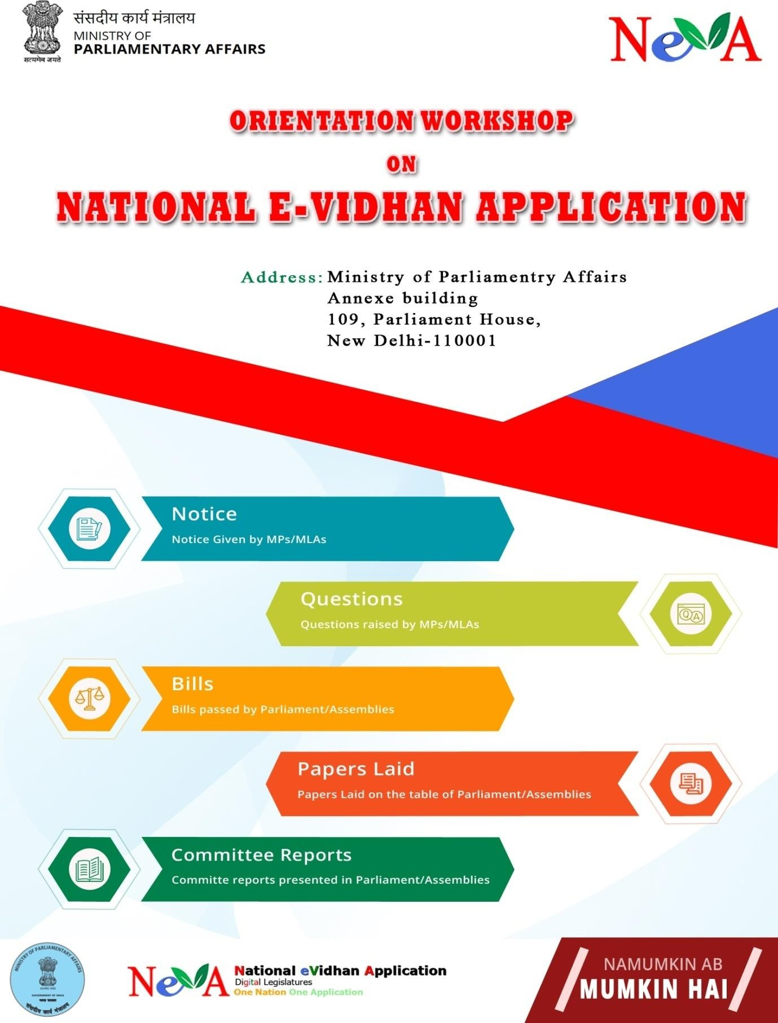

Brief Report on

Phase II Training Workshop on “National e-Vidhan Application (NeVA)” Conducted at CPMU NeVA for Assam Legislative Assembly
From 27thMay to 29thMay, 2019

A three day Phase II Training Workshop on National eVidhan Application (NeVA) was organized at CPMU NeVA Parliament Annexe. The Workshop was organized by the Central Project Management Unit (CPMU) of Ministry of Parliamentary Affairs (MoPA), Government of India for Assam Legislative Assembly Secretariat from 27thMay to 29thMay, 2019.

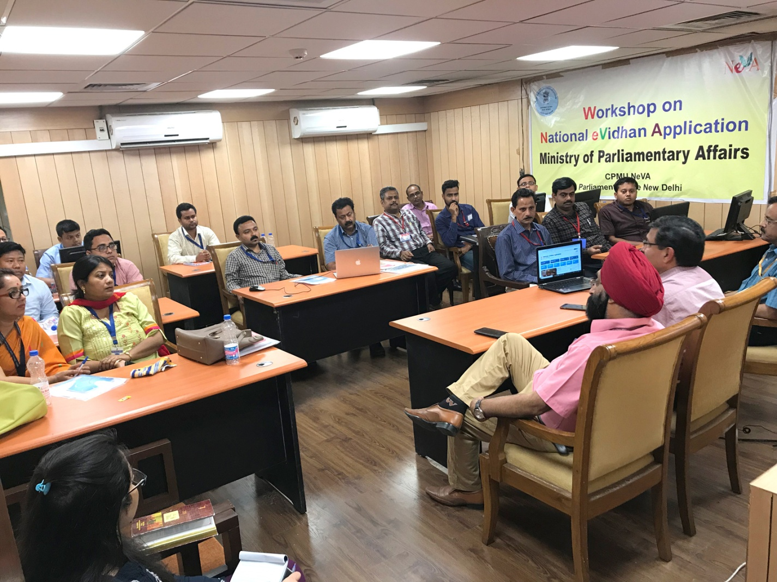

The inaugural session was attended by Dr. Satya Prakash, Joint Secretary, MoPA, Government of India , Shri N.S. Arneja, DDG NIC, Shri S.K. Sinha, STD NIC and participants from Assam Legislative Assembly comprised various Nodal Officers and staff personnels wherein the latest redesigned version of NeVA application was briefed along with the future plans to propel this project by Dr. Satya Prakash, Joint Secretary.

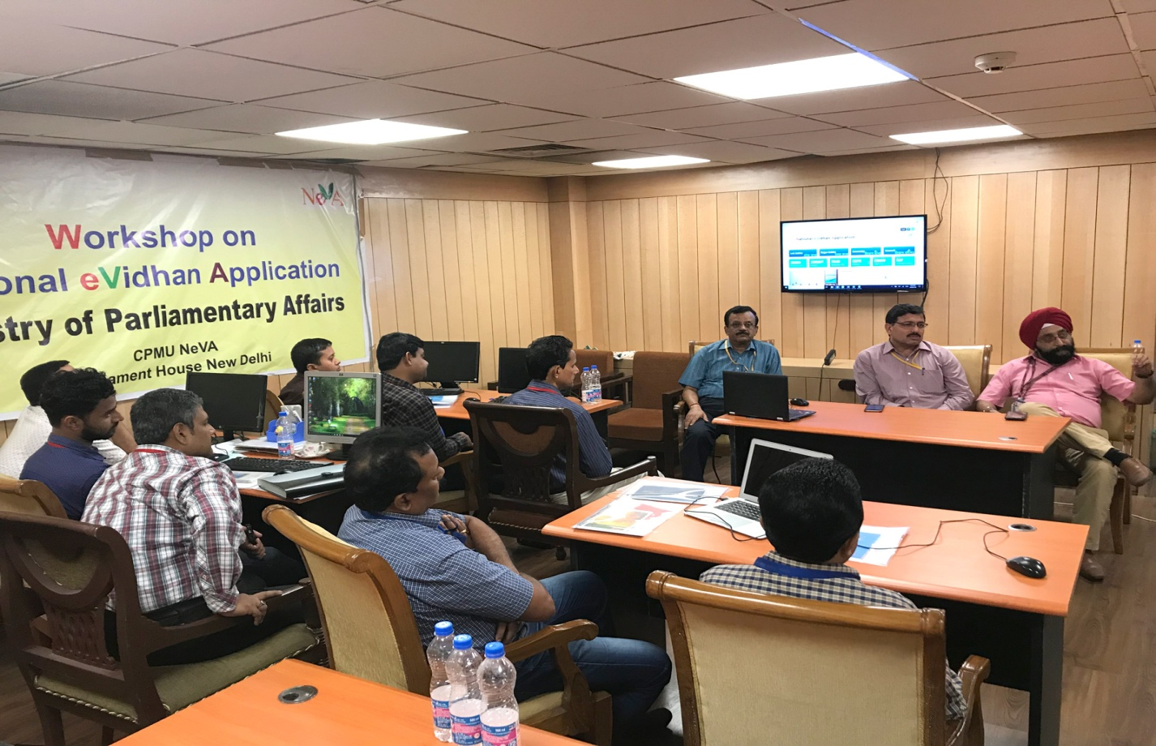
On the first day Mr. Arpit Tyagi & Ms. Priyanka Barthwal, NeVA coordinators; the resource persons from the Central Project Management Unit under Ministry of Parliamentary Affairs, Government of India, New Delhi gave a detailed account of the current updated version of NeVA with the new design and some of the latest incorporated functionalities in the software. Besides that, two technical sessions followed with a complete overview of the core functionality of the software application which included the modules like Master Data entry Module, Question Module, Department Module & LOB Module.

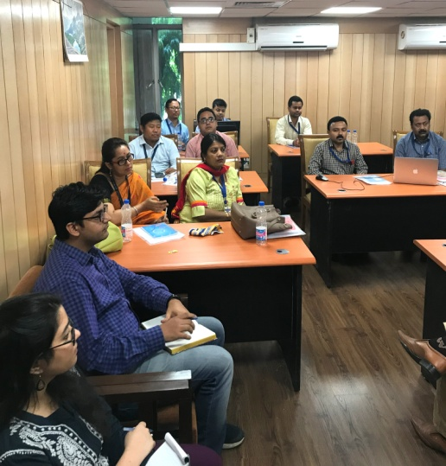
During the afternoon session issues relating to working on the NeVA application in Assam Legislative Assembly were discussed in length.

The officers and other personnels were encouraged to come up with the suggestions or further ideas that would help in taking this project to the next orbit.

On the second and the third day of the workshop the participants were made to do extensive data entry apart from the work flow based question processing as well as the LOB generation through the web application with the help of CPMU team members. During the hands on experience various issues faced by the participants were resolved as well as other technical queries were also noted down.
Shri Hitendra Nath Goswami, Hon’ble Speaker, Assam Legislative Assembly had already shown a keen interest in computerization and digitization of Assam Legislative Assembly and had desired to go ahead with NeVA project at the earliest so as to facilitate the Hon’ble Members of Assam Legislative Assembly and public at large. In a concerted effort towards capacity building measures, the three day workshops are being conducted to familiarize more number of officials with the software who will be able to transfer knowledge further to the other officials and so on. Assam has shown tremendous level of zeal and cooperation in adopting the project and keeping up a great performance till date and is one of the leading States across India to grasp the opportunity to get the workshop held in its Vidhan Sabha besides successful completion of the Phase II Training workshop at CPMU NeVA.

The valedictory session was presided over by Dr. Satya Prakash, Joint Secretary, MoPA, Government of India ,Shri N.S. Arneja, DDG NIC, Shri S.K. Sinha, STD NIC, Mr. Arpit Tyagi & Ms. Priyanka Barthwal, NeVA coordinators; the resource persons from the CPMU with the felicitation of the participants with the certificates of participation as a gesture of appreciation and encouragement.

