1. DFD for Bills Module

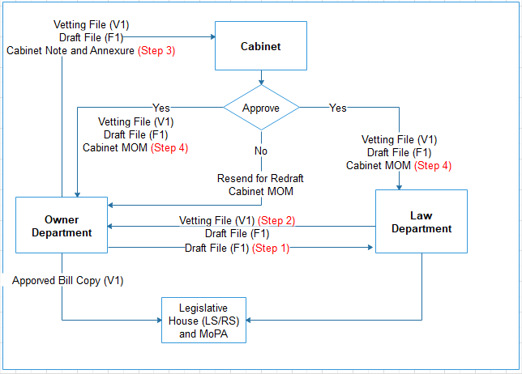

Flow Chart Depicting Process of Bill Drafting by

Owner Dept., Legislative Dept. & Cabinet