

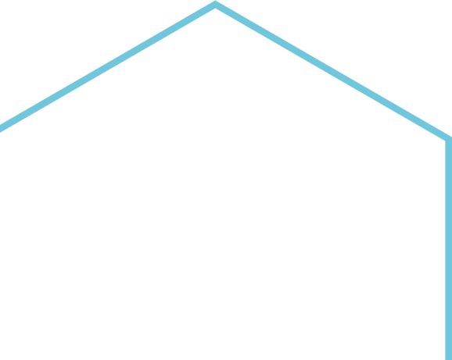

|  |
| --- |
|  |
| **Data Flow Diagram for All Modules** |
|  |
|  |
|  |
| **Central Project Management Unit National eVidhan Application** Ministry of Parliamentary Affairs  109, Parliament House, New Delhi-110001 |



1. **Bills Module🡪**

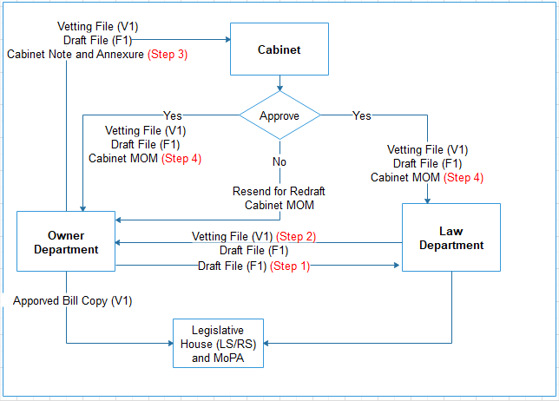

Flow Chart Depicting Process of Bill Drafting by

Owner Dept., Legislative Dept. & Cabinet

1. **Reporter Module🡪**

|  |  |
| --- | --- |
| Entity1 | 1. Create Time Slots. 2. Assign Time Slots to Reporter   Chief Reporter Login   1. Merge or edit the turn file which is submitted by reporters 2. Publish all verbatim on Public Portal |
| Entity2 | 1. Prepare turn files like audio file, LOB , Starred, Unstarred files etc. 2. Submit the turn file and audio to Chief Reporter   Reporters Login  Turn file sent to  Chief Reporter |

1. **List Of Business Modules🡪**

|  |  |
| --- | --- |
| Entity1 | 1. Login LOB user id and password to perform LOB operations.   Login with LOB User ID |
| Entity2 | 1. Create new house agenda 2. Select Session date , Event type ,Serial no.,   Create List of Business  Content of business, Choose pdf files.   1. Finally save the LOB data |
| Entity3 | 1. Pending LOB will be show here 2. Use click on ‘Tick’ button to send LOB to Secretary for approval   List of Pending LOBs   1. User can modify the LOB data as per need. |
| Entity4 | 1. All the LOBs will shown with details like, Submitted date, LOB as PDF and status.   List of Submitted LOBs |
| Entity5 | 1. Approve or Reject the LOBs. 2. Generate LOB E-Book   Login with Secretary |
| Entity6 | 1. Admin user select the session date and select the questions which wants to transfer to house.   Login with Admin   1. Select ‘Paper Laid in House’ tab, select the session date and select which LOBs are to be laid and then laid that LOB. |
| Entity7 | 1. All LOBs will be display on NeVA Public Site   LOB Show on Public Portal |

**4. Department Modules🡪**

|  |  |
| --- | --- |
| Entity1 | Login with Department |
| Entity2 | 1. Departmental user select the Starred, Unstarred, Notice questions.   Starred/Unstarred/  Notices |
| Entity3 | 1. User Select pending for reply.   Pending for Reply   1. Select question to which reply need to be added. 2. Update the question with content , doc and pdf files and then click on update button. |
| Entity4 | 1. Only reply will be sent to Vidhan Sabha whereas Reply & Supplementary will be sent to the concerned Minister   Draft Reply |
| Entity5 | 1. All sent Question will be shown here.   Reply Sent |

**5. User Management Modules🡪**

|  |  |
| --- | --- |
| Entity1 | 1. Username : nevauser and password: welcome   Login with NeVA User |
| Entity2 | 1. Fill the information like, Name, DOB, Photo, Address, Mobile etc.   Fill User Registration form   1. Click on save button then user name and password will created and display in login page. |
| Entity3 | Login with newly created user ID and password |
| Entity4 | 1. Click on profile update and update necessary information   Profile Update   1. If user type Legislative house and sub user type is Member of house then request send to Super Admin otherwise request goes to Administrative Head |
| Entity5 | 1. Select access control list and send request to assign role.   Send Request |
| Entity6 | 1. Login with SuperAdmin or Secretary Head to approve the access control list   Login Super Admin/  Secretary Head   1. If request is approve by them new user will be able to perform related task. |

**6. Committee Modules🡪**

|  |  |
| --- | --- |
| Entity1 | Login with Committee User |
| Entity2 | 1. After login click on Legislature Committees tab then click on Committee Type Master.   Committee Type Master   1. Create Committee Master with name, name in local, abbreviation. |
| Entity3 | 1. Create the committee by selecting committee type master, committee name, committee name in local etc.   Committee Creation |
| Entity4 | 1. Create the committee formation by given mandatory data like, committee type, committee Name, formation date etc.   Committee Formation |
| Entity5 | 1. Mapping chairman & member within the committee. 2. In the event of Bi-Cameral House, a user has to select members from both houses.   Committee Constitute   1. In the event of Uni-Cameral House, data from only one house . |
| Entity6 | 1. Create Committee Room so that Committees can perfomr there task with suitable space and envirnoment.   Committee Room   1. Enter room details like, committee room name, room address, sitting capacity etc. |
| Entity7 | 1. Room can be booked by some details like, Committee type. Committee name, booking type, meeting date etc. First check availabilty then book room finally.   Committee Room Booking   1. In case of Bi-Cameral House, rooms can be selected from bith the houses. |
| Entity8 | 1. An Administrative of NeVA approve and reject the request by clicking on action button   Committee Approving Room Booking   1. Before approval of the room admin user needs to check the availabilty of room by clicking on ‘Check Availabilty’ |
| Entity9 | 1. Admin user need to select user from list , committee and committee type.   Committee Permission |

**E- File System for Committee Module🡪**

|  |  |
| --- | --- |
| Entity1 | Login with Committee  User |
| Entity2 | 1. Click on House committee then click on ‘File’ to create E-Files.   Files   1. ‘Click on Add New E-File’ and fill necessary information like, committee, department, e File type etc. then click on ‘Save’ button. |
| Entity3 | 1. For drafting a new papers, a user has to click on ‘Draft Papers’ 2. Then user need to fill mandatory information like, committee details, send & paper details etc. 3. For sending ‘Draft’ to department ,member & committee chairmen user has to click on plus(+) sign 4. After click on plus(+) sign, new form will open where user has to select department, member, committee chairman and then click on ‘Next’ button.   Draft Papers   1. For attaching multiple file user have to check the checkbox and then click on ‘Attach Multiple Paper to E-File ’ 2. For Noting process, user has to ‘Assign branch & employee’ select them and assign them. 3. After assigning draft from higher authority to department, the concerned user login and sent the document to selected recipient. 4. One the e-file sent to higher authority , the sender can’t make any changes. |
| Entity4 | 1. Once the e file is approved & sent by the branch, it will autometically visible in the ‘Sent papers’ menu   Sent Papers   1. Committeee user can the paper by ‘my papers’ & ‘All papers’ 2. An authorized user can able to Publich or UnPublish the docuemnts. |
| Entity5 | 1. Whatever the ‘Replies or any other documents’ are received from the government department , it will be display in list of ‘Received Papers’ tab.   Received Papers |
| Entity6 | 1. Committee data will show on Public Portal 🡪 Committee🡪Formation |

**7. Members Modules🡪**

|  |  |
| --- | --- |
| Entity1 | Login with Super Admin User |
| Entity2 | 1. After login with Super admin click on ‘Member Details’ tab the click on ‘Member’ tab   Members   1. Click on ‘Create New’ button then fill the necessary information and then click on ‘Save’ button to save the member information. 2. The list of member is display. |
| Entity3 | 1. Click on ‘Member House’ tab then click on Create New.   Members House   1. Fill the necessary information related to member and house and click on ‘save’ button. 2. When the data is to be saved it will show on the Public Site of NeVA |

**For any feedback/comments**

Please write to NeVA CPMU Cell

109-110 Parliament House Annexe Sansad Marg, New Delhi-110001 Email: [helpdesk-neva@gov.in](mailto:helpdesk-neva@gov.in) Phone: 011-23034109