Diary Login

* In Diary login help button at the top left corner is not working.
* If we click on home page it is not redirecting to there.
* Under starred question if we click on new button there is no information in department combo box.

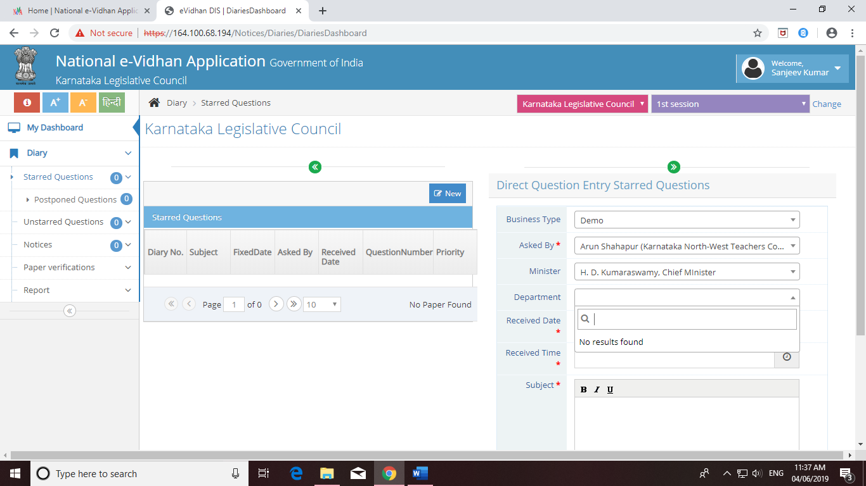

* Same problem in Unstarred questions and notices tab also(Department).
* In paper verifications tab if we click on verified papers it shows error like below. That is we are not able to select the date there.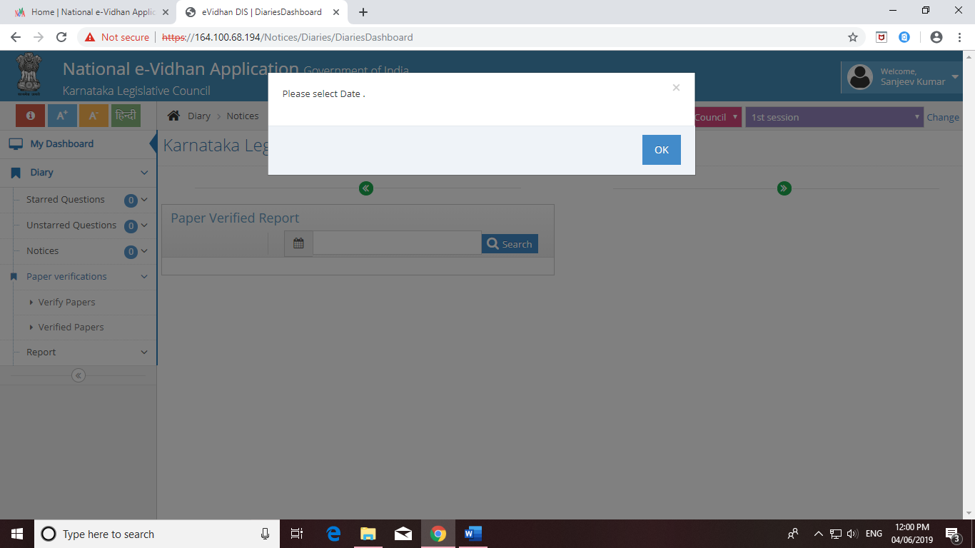
* While taking print only print of the question is necessary instead of home screen icons.

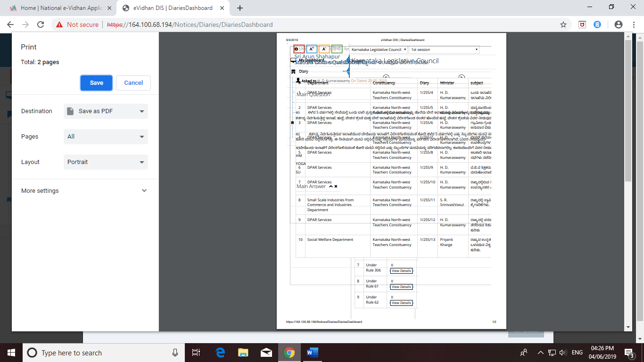

* Displaying of diary number is not in proper format, it should display the diary number along with the respective session.

