|  |
| --- |
|  |
|  |
| **Bill Management Process** |
| **User Guide(Secure Login)** |
| **Version 1.0** |
| **Document Id: NeVA/CMS/BMP/UG/1.0** |
| **Central Project Management Unit**  **National eVidhan Application**  Ministry of Parliamentary Affairs  109, Parliament House, New Delhi-110001 |

|  |
| --- |
|  |

# ABSTRACT

Digital Legislature is defined as the use of ICTs in legislative institutions across the country, whether in Union/State with the objective of enhancing and strengthening their core functions and operations which helps in strengthening the interaction between the members of Legislative Houses (Parliament or State Legislative Houses) and the citizens.

In this direction, NeVA ( National e-Vidhan Application ) is a noble initiative of the Government of India under the Digital India Programme involving a multi-pronged approach to cater to the requirements of the various sections of the Government and the Legislatures all across the country and facilitating the close coordination among them on the single digital platform.

NeVA is a web based cum mobile based application which is compatible for both the android as well as the iOS platforms. It is an integrated platform consisting of the various modules performing specific roles for facilitating the House Business. These modules comprises the question and notices submission by the members, Reply submission by the Department section, Creation of the master data and the public site settings through the Admin and the Super Admin, Drafting of the Bills by the Department, management of the committee functions by the respective section, etc.

The need to develop this application arose from the very fact that the current functioning of the legislatures is being performed manually in various departments leading to the latency in the overall functioning of the House Business. In the dire need to transform the work of the legislatures, the NeVA application serves to the fullest, all the requirements of legislatures, the government departments and the other organs.

These various modules are interlinked with each other in such a way that functioning of one depends on the other. The tasks performed by the different modules can be seen on the public site of the respective legislatures in the form of the laid documents.

In this way the application is useful for the various stakeholders like Members, Ministers, Assembly Secretariat officials, Government Departments, Legislative section, Committees sections, Table office etc.

NeVA application facilitates members and the other stakeholders to work in an integrated manner on the single platform and also have the access to the information through the mobile and the web application. Not only this, it is helpful for the citizens also who will be able to access the information about any legislatures in uniform fashion, all across India and stay informed thereby strengthening the democracy.

Table of Contents

ABSTRACT 1

TABLE OF FIGURES 3

INTRODUCTION 4

Finding the Application (Site Login Page) 5

NEW USER REGISTRATION 5

DIAGRAMATIC PROCESS FLOW OF THE BILL MANAGEMENT SYSTEM 5

DRAFTING BILL AND SENDING FOR VETTING 6

VETTING THE DRAFT BILL AND RESEND TO OWNER DEPARTMENT 7

VETTED BILL WITH SUPPORTING DOCUMENTS IS SENT TO CABINET FOR APPROVAL 8

DRAFT BILL FOR THE CABINET APPROVAL TO RESEND TO THE OWNER DEPARTMENT 9

SENDING CABINET APPROVED DRAFT BILL TO THE LEGISLATURE AND PARLIAMENTARY AFFAIRS DEPARTMENT 10

OPTIONAL PROCESS: SENDING THE CABINET APPROVED BILL TO THE BICAMERAL STATE LEGISLATURE AND PARLIAMENTARY AFFAIRS DEPARTMENT 11

BICAMERAL STATE LEGISLATURE LOGIN TO VIEW AND PROCESS THE GOVERNMENT BILLS 12

STATE LEGISLATURE TO VIEW AND PROCESS THE DRAFT BILLS (INPUT SCREEN AND OUTPUT: TO BE INTRODUCED AND AS INTRODUCED BILL COPY) 13

ADVANCE COPY OF “TO BE INTRODUCED” IS AVAILABLE AT MPS/MLAS LOGIN 15

AS INTRODUCED BILL COPY IS SENT TO OTHER LEGISLATURE HOUSE 16

BILL COPY AVAILABLE AT “LIST OF BUSINESS” FOR MAKING LOB OF THE DAY 17

# TABLE OF FIGURES

Figure 1: Flow chart depicting the process of Bill Management System 8

Figure 2:Drafting New Bill 9

Figure 3: Sending draft Bill for vetting or directly to House 10

Figure 4: Vetted Draft Bill and sending back to the owner dept. Or directly to House 11

Figure 5:Sending draft for cabinet Approval 12

Figure 6:Attaching cabinet note and resending to owner department 13

Figure 7:Sending Draft Bill to legislature or Ministry of parliamentary affairs 14

Figure 8:Optional sending of Bill to Bicameral Legislature or Parliamentary Affairs department 14

Figure 9:Bicameral Legislature processing of govt. Bill 15

Figure 10:Checking various details and amendment of Bills by other house 16

Figure 11:Generate and Publish the “to be Introduced” copy of Bill 16

Figure 12:Different options in :As Introduced” Bill functionality 17

Figure 13:As passed Bill copy 17

Figure 14:Advanced copy of “to be introduced” Bill 18

Figure 15: “As introduced copy of Bill” for other house 19

Figure 16: Bill copy available at List of Business for making LOB of the day 20

# INTRODUCTION

This module is named as “Bill Management Process Module”. A Bill is proposed legislation under the consideration by a legislature. A Bill does not become a law until it is passed by the legislature and, in most cases, approved by the executive. This module is designed to provide firsthand information to the prospective users of NEVA platform about the process through which a stakeholder/user can engage him in various stages of bill management i.e. the stages through which a “prospective Bill” finally becomes an “Act” on NEVA platform.

Different stakeholders/users have different roles, duties, powers, functions etc. in the process of Bill management. The NEVA platform integrates all these stakeholders on a common platform and ensures free flow of information between these stakeholders. In this context this modules gives an insight about how these different stakeholders are integrated and how the flow of information takes place and in this way educates these stakeholders on whole of the online/web-based process through which a Bill becomes an Act. The Bill after its passage in the Houses gets automatically available in the public website after its notification in the e-Gazette and is available to be accessed by the users in the public domain.

Different stakeholders/users involved in Bill management process are mentioned below:

Central Government

* Owner Department
* Central Ministers
* Legislative Department
* Cabinet
* Ministry of Parliamentary Affairs
* Parliament (Rajya Sabha and Lok Sabha)– Their staff and MPs.

State/UT Legislative House – Their staff and MLAs.

* State Government
* Owner Department
* State Ministers
* Legislative Department
* Cabinet

**This User Guide explains the process involved in the Bill drafting by Owner Department, vetting by the Legislative Department and the approval by the Cabinet and also the further processing of the Draft Bill by the House Secretariat(s) till its passage and becoming an Act through NeVA CMS**

# Finding the Application (Site Login Page)

The user can enter the URL <https://cms.neva.gov.in/> in the browser, which will be redirected to the login page displaying a form wherein the login credentials of the user will be entered.

# NEW USER REGISTRATION

In order to engage in various aspects of Bill Management process, a person should first register himself as a user in appropriate NEVA unit (various profiles mentioned as different stakeholders) using the process explained in “USER REGISTERATION PROCESS” module.

# DIAGRAMATIC PROCESS FLOW OF THE BILL MANAGEMENT SYSTEM



Figure 1: Flow chart depicting the process of Bill Management System

# DRAFTING BILL AND SENDING FOR VETTING

The first stage in the Bill Management process involves Drafting of the proposed Bill (Legislative proposal). The Drafting is usually done by owner department i.e. the department which deals with the subject matter of Bill and the source of origin of the Bill. So, firstly the owner department has to into NeVA Bills login module and has to go to the Bills tab and click on the “Draft Bill” tab. After clicking on “New” button, the Draft Bill form will be displayed which is shown below. After filling up all the necessary details in the Draft Bills form, you have to click on the save button for saving your draft Bill data.

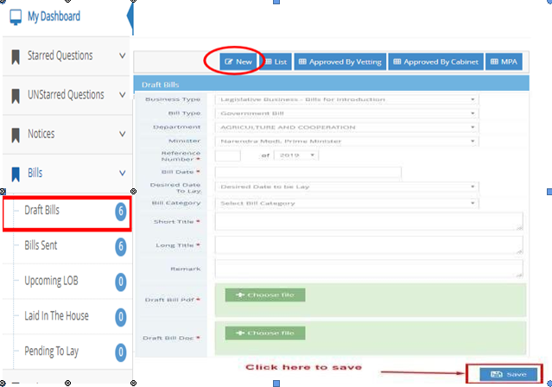

Figure 2:Drafting New Bill

After saving the data, your draft Bill will be displayed under Draft bills list. The user has to check the checkbox and click on the **send button** (“Send for vetting”) to send the Draft Bill to Legislative Department for vetting of the proposed Legislative Proposal. If Owner department wants to send the Draft Bill directly to the associated State Legislature without vetting, then please click on **Send button** (“Sending of Bills to House”).

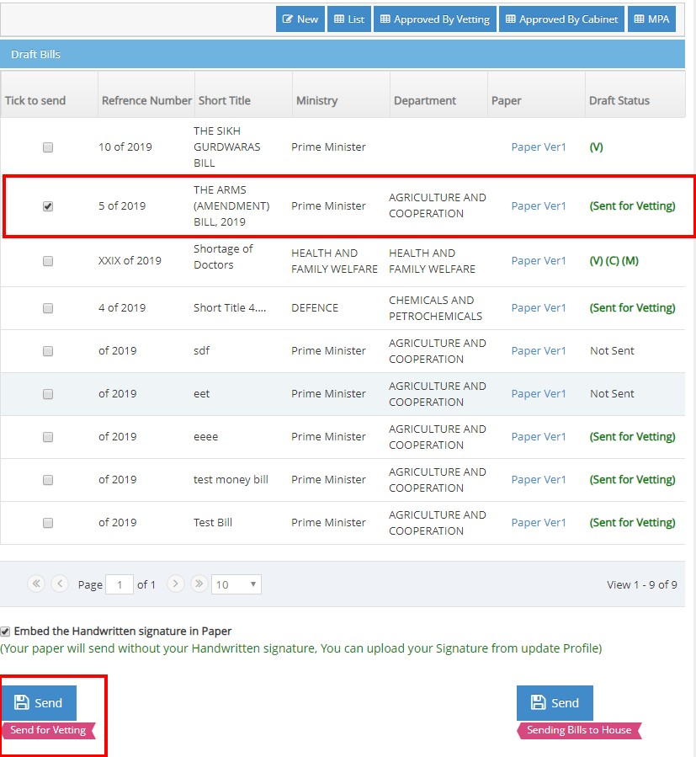

Figure 3: Sending draft Bill for vetting or directly to House

# VETTING THE DRAFT BILL AND SEND BACK TO OWNER DEPARTMENT

In this stage the draft Bill received by Legislative department from the owner department is vetted, for which legislative department login is created. After vetting the Bill, it is sent back to the owner department. The user has to go to the **Bills tab** 🡪 Draft Bills. After clicking on the particular Draft Bills, the Update Bill Draft form will be displayed which is shown below in the screenshot. After filling up all the necessary data i.e**. “ Vetting date ”**, **‘‘ Vetting PDF file’’** & **‘‘vetting Doc file’’** in the update Bill Draft form, the user has to click on the **Update button** for updating the draft Bill data returned by the Legislative department.

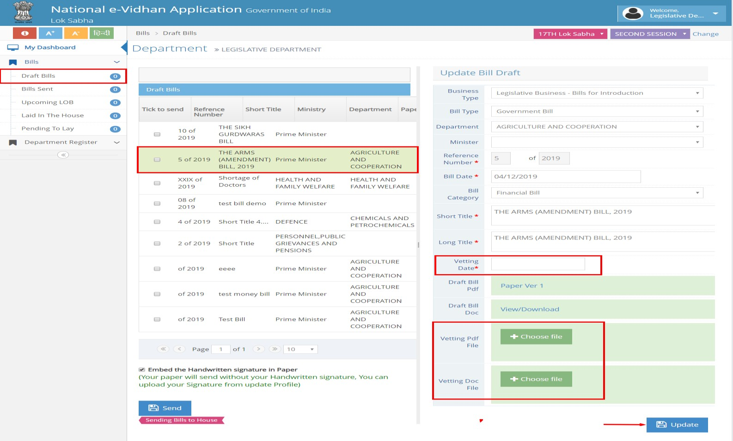

Figure 4: Vetted Draft Bill and sending back to the owner dept. Or directly to House

# VETTED BILL WITH SUPPORTING DOCUMENTS IS SENT TO CABINET FOR APPROVAL

In this process, the user has to login with the owner department. Then the user has to go to the **Bills tab** 🡪 **Draft bills**. After clicking on the **“Approved by vetting”** button, all the Draft Bills which have been vetted will be displayed. The user has to click on the **Update** button for updating your draft Bill data. The updated Bill is sent to the Cabinet for approval.

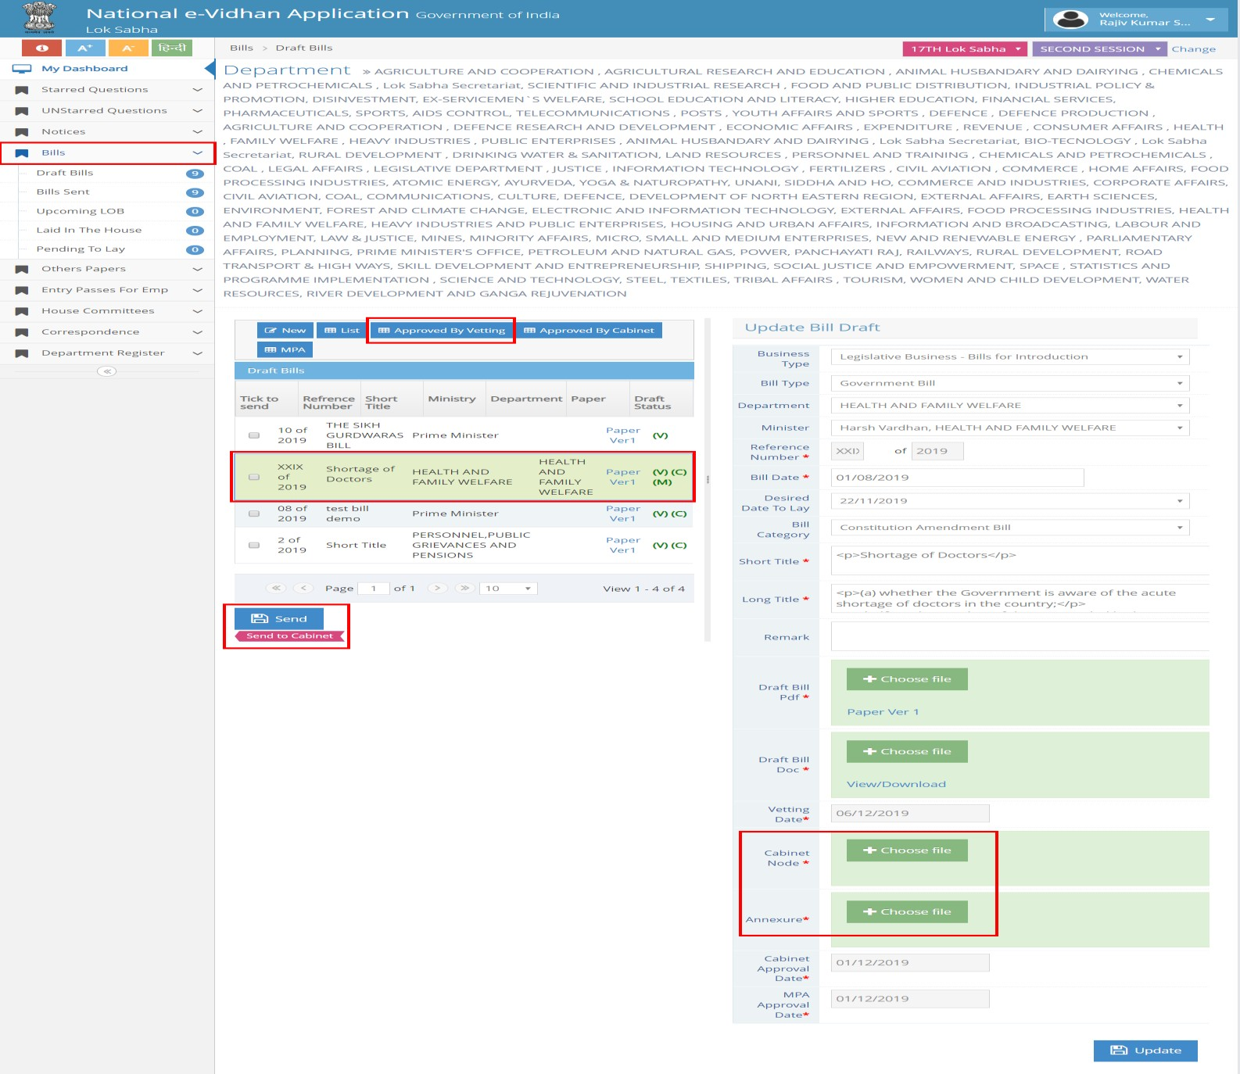Figure 5:Sending draft for cabinet Approval

# CABINET APPROVAL OF THE BILL & TO SEND BACK TO THE OWNER DEPARTMENT:

In the Cabinet login, the user will select any particular draft Bill received from the owner Department for approval of the Cabinet. The user has to update **“Cabinet Minutes of Meeting”**, and then click on the **Update button** for updating the draft Bill data.

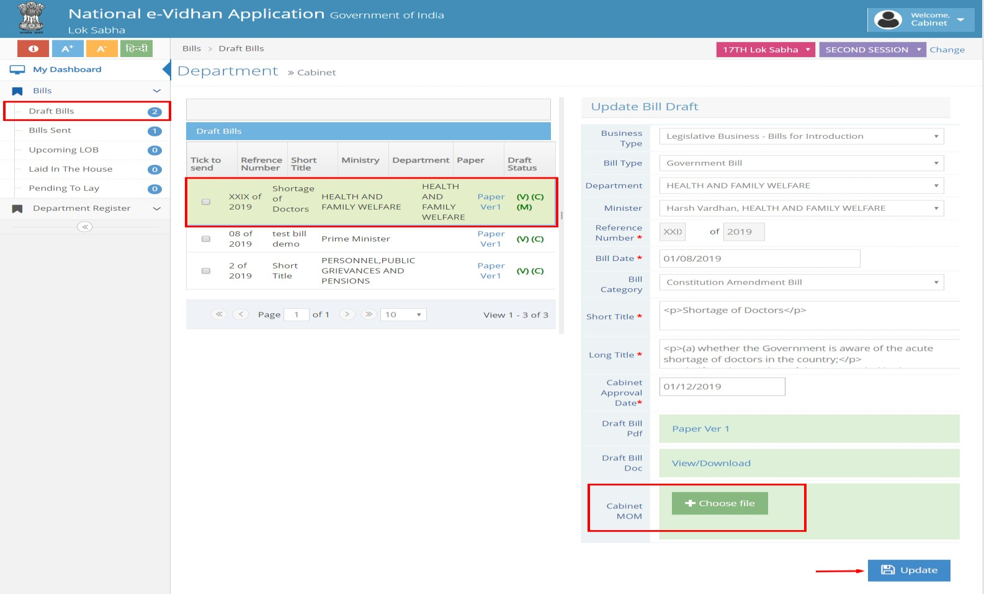

Figure 6:Attaching cabinet note and resending to owner department

# SENDING OF CABINET APPROVED DRAFT BILL TO THE LEGISLATURE AND PARLIAMENTARY AFFAIRS DEPARTMENT BY THE OWNER DEPARTMENT:

In this process, user has to login with the owner department credentials. Then user has to go on **Bills tab** 🡪 **Draft bills**. After clicking on the **“Approved by Cabinet”** button, all the **“Cabinet Approved Draft Bill”** will be displayed in the list. Then check the checkbox of the particular “Draft Approved Bill” item. If the user wants to send the Cabinet Approved Draft Bills directly to house, then he/she can click on **send button** (“Send Bill to house”) or can send the Cabinet Approved Draft Bills to Parliamentary Affairs Department (depending upon the procedure followed in each state/Legislature) by clicking on the **send button** (“Send to MPA”).

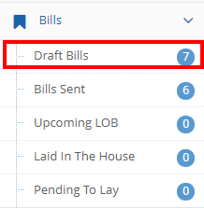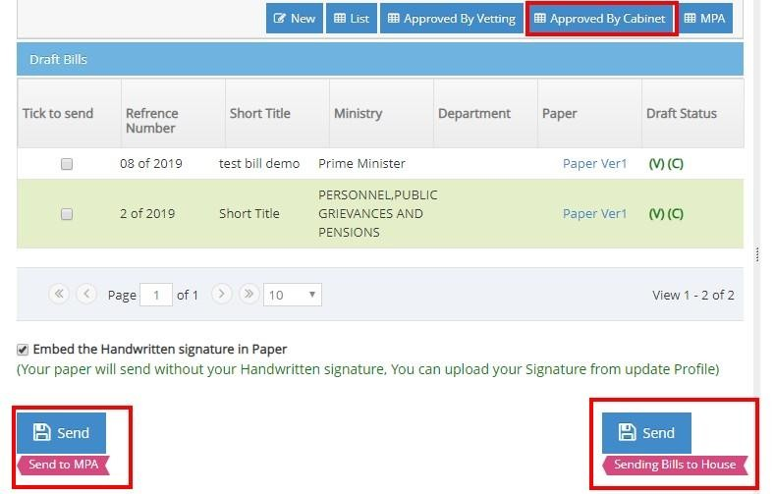

Figure 7:Sending Draft Bill to legislature or Ministry of parliamentary affairs

# OPTIONAL PROCESS:

# SENDING THE CABINET APPROVED BILL TO THE BICAMERAL STATE LEGISLATURE AND PARLIAMENTARY AFFAIRS DEPARTMENT

In this process, the user has to login with the Legislative Department which has the option to send the final Bill copy to either of the two Houses in case of bicameral State Legislature.

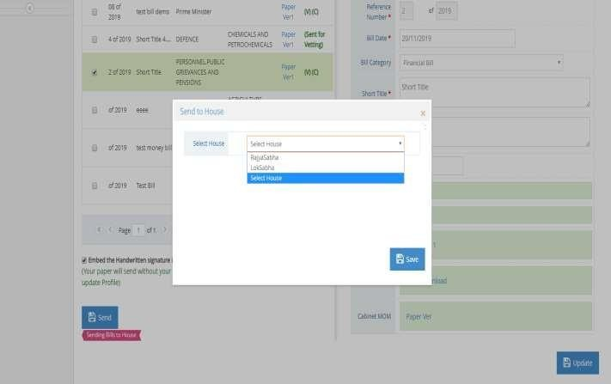

Figure 8:Optional sending of Bill to Bicameral Legislature or Parliamentary Affairs department

# BICAMERAL STATE LEGISLATURE LOGIN : TO VIEW AND PROCESS THE GOVERNMENT BILLS

In this process, the user will login with the **“State Legislative Department”**. In this login, one can view and update the draft Bill which he/she has received from the Government Department.

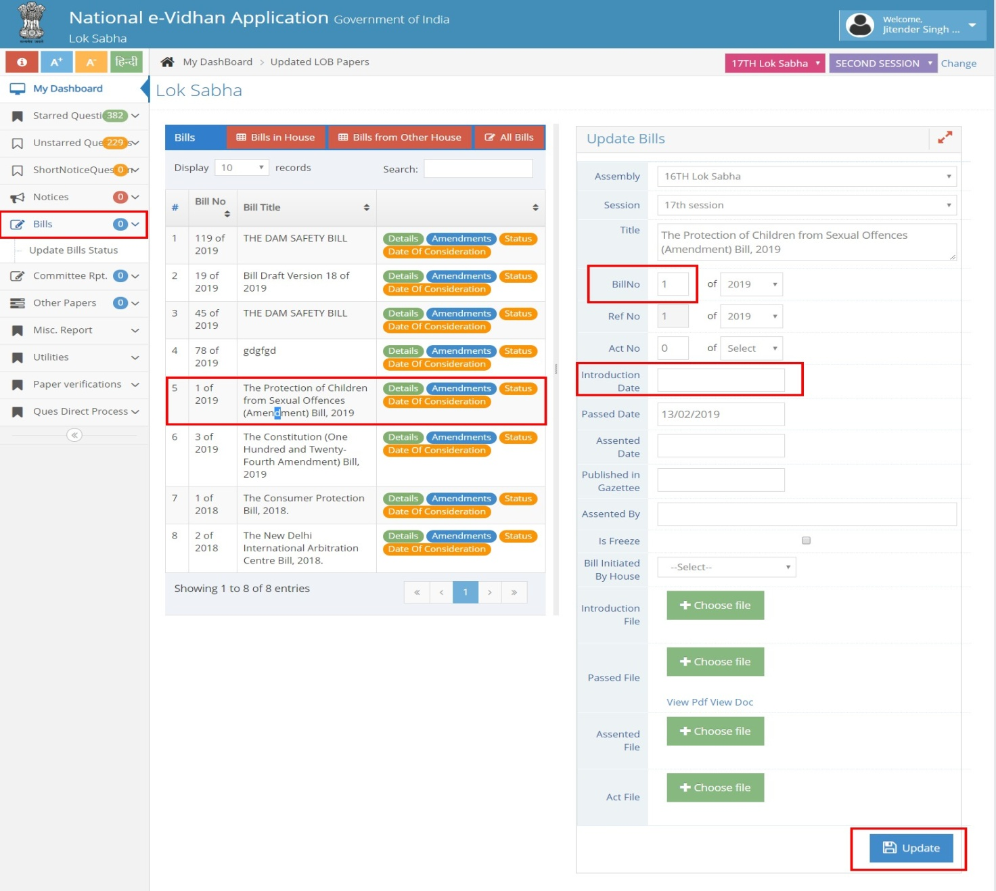

Figure 9:Bicameral Legislature processing of govt. Bill

From the State Legislature login, a user can view the ‘Details of the Bill’, ‘Amendments of the Bills’, ‘Status of the Bill’, & ‘Date of consideration’ of the Bill. To view & Update the Draft Bill Details , the user needs to click on the “Detail” Button. Then, to update the **“Amendment”** of the particular Draft Bills, the user needs to click on the **“Amendment”** button for Viewing, Adding, Deleting and Editing of Amendments to Bills.

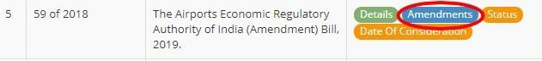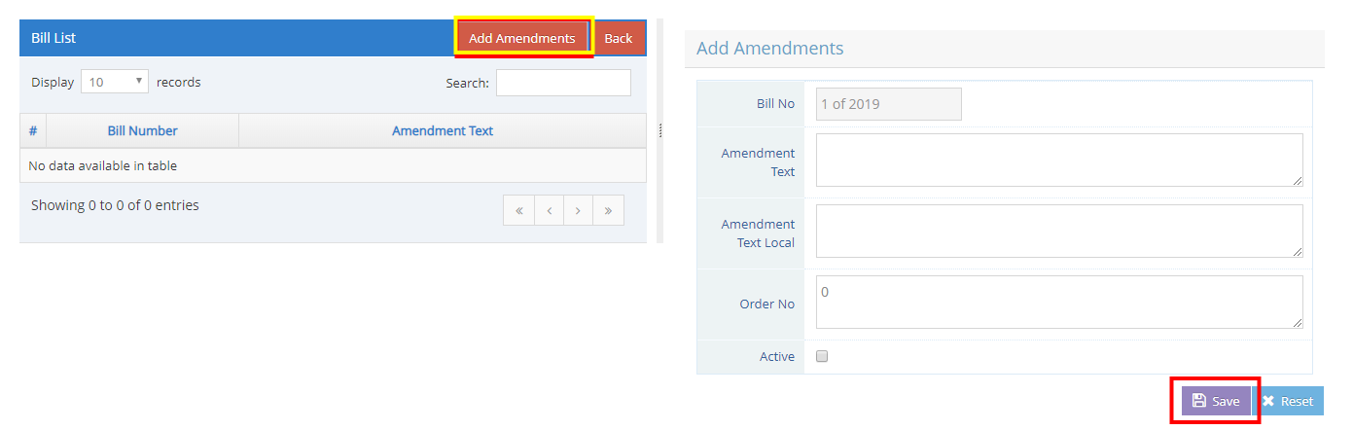

Figure 10:Checking various details and amendment of Bills by other house

Similarly to update the **“Bill Status”** or the **“Date of consideration”** of the particular Bill, a user needs to click on the **“Status”** or the **“Date of consideration”** button for Viewing, Adding, Deleting and Editing of information.

# STATE LEGISLATURE TO VIEW AND PROCESS THE DRAFT BILLS (INPUT SCREEN AND OUTPUT: TO BE INTRODUCED AND AS INTRODUCED BILL COPY)

“TO BE INTRODUCED” FUNCTIONALITY : “Publish to be introduced Bill Copy”🡪

Through this, the user can generate “To be Introduced” Bill copy for a particular Bill.

“Publish”🡪 Through this, a user can publish the generated “To be Introduced” Bill copy to the Member of the State Legislature.

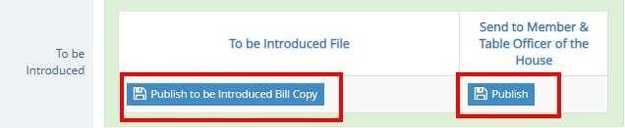

Figure 11:Generate and Publish the “to be Introduced” copy of Bill

**“AS INTRODUCED” FUNCTIONALITY**

**“Publish As introduced Bill Copy”:** Through this, a user can generate and publish “As Introduced” Bill copy for the particular bill.

**“Send to e- gazette”** : Through this, user can confirm that they provided “As Introduced” Bill copy to the e-gazette Office.

**“Send to Other House”:** Through this, a user can transfer or send the “As Introduced” Bill copy to the other State Legislature House (in case of Bicameral State Legislature).

**“Send to House Committee”:** Through this, a user can send the **“As Introduced”** Bill copy to the House Committee for further legislative scrutiny by the parliamentary committee and to get the recommendations.

Figure 12:Different options in :As Introduced” Bill functionality

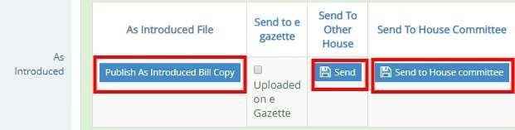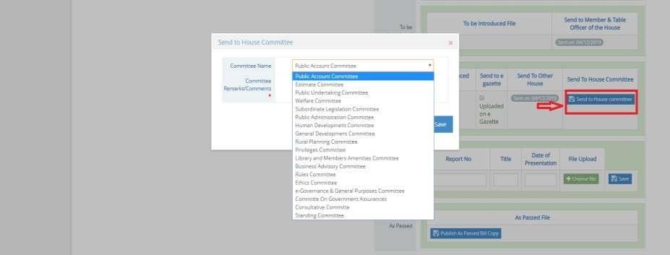

**“As passed Bill copy” functionality:** Through this, a user can publish the “As Passed” Bill copy for a particular Bill.

Figure 13:As passed Bill copy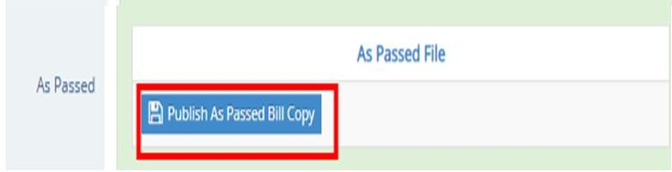

# ADVANCE COPY OF “TO BE INTRODUCED” IS AVAILABLE AT MPS/MLAS LOGIN

In MPs/MLAs login, Advance copy of **“To be introduced”** Billis available at Assembly Bills tab.

Figure 14:Advanced copy of “to be introduced” Bill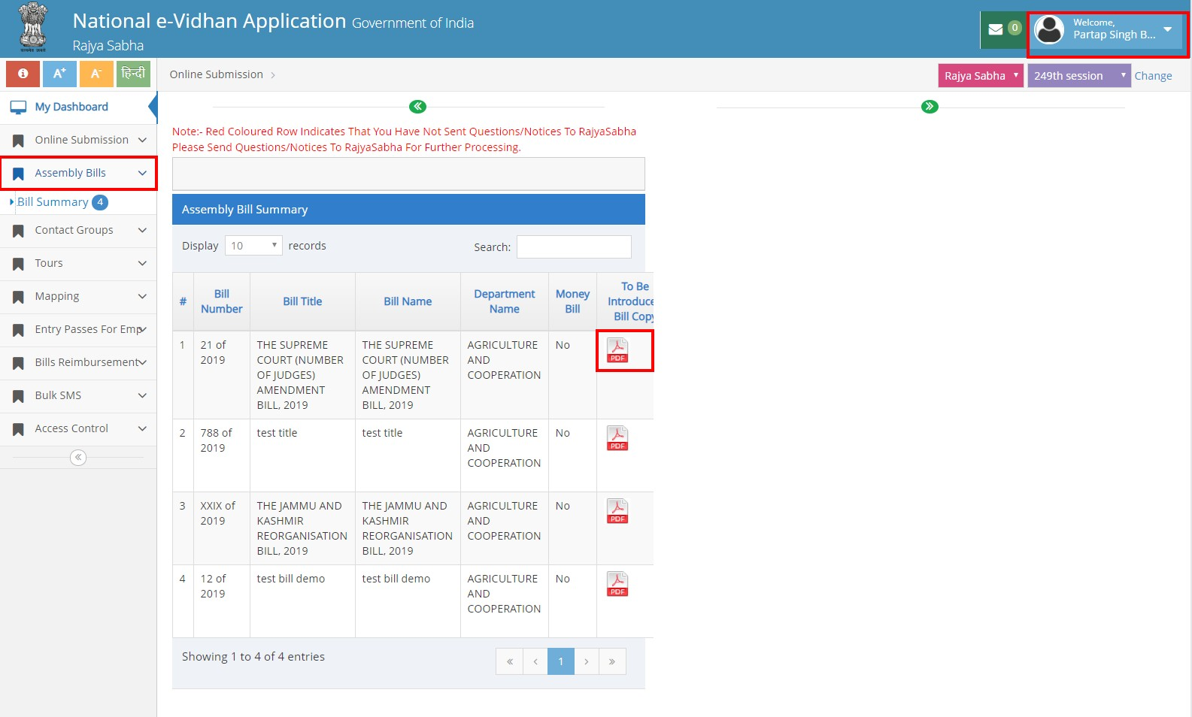

# AS INTRODUCED BILL COPY IS SENT TO OTHER LEGISLATURE HOUSE

To view the State Legislature Bill copy, a user can click on **Bills** 🡪 **Update Bill** status tab **“Bill from the other house”** in case of bicameral state legislature.

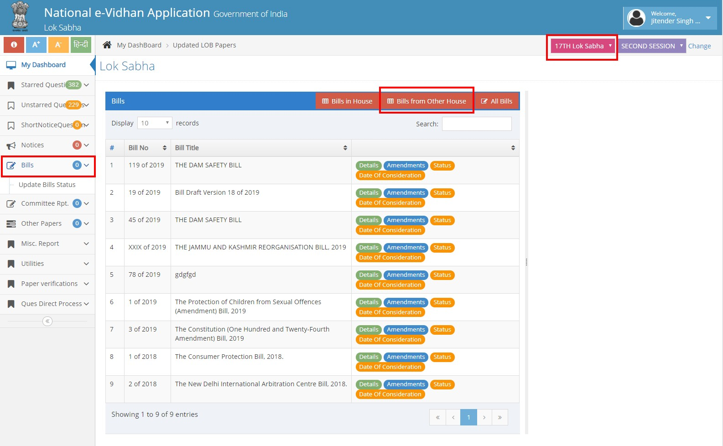

Figure 15: “As introduced copy of Bill” for other house

# BILL COPY AVAILABLE AT “LIST OF BUSINESS” FOR MAKING LOB OF THE DAY

The user can view and attach the required Bill copy from the **“view paper”** & **“Show paper”** button from list of business login.

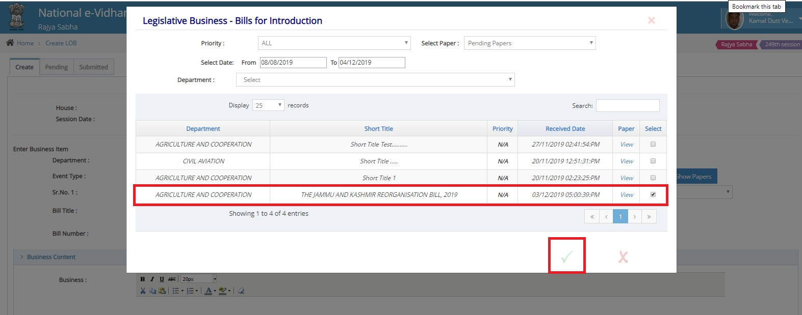

Figure 16: Bill copy available at List of Business for making LOB of the day

# ACCESS TO BILLS DATABASE ON NEVA PUBLIC PORTAL

All the Bills introduced, Passed by the respective House can be viewed/accessed from the respective State Legislature NeVA Home Page under the Legislation tab.

