**User Manual of Bills Management Systems**

(For Unicameral & Bicameral legislatures)

**Flow Chart Depicting Process of Bill Drafting**

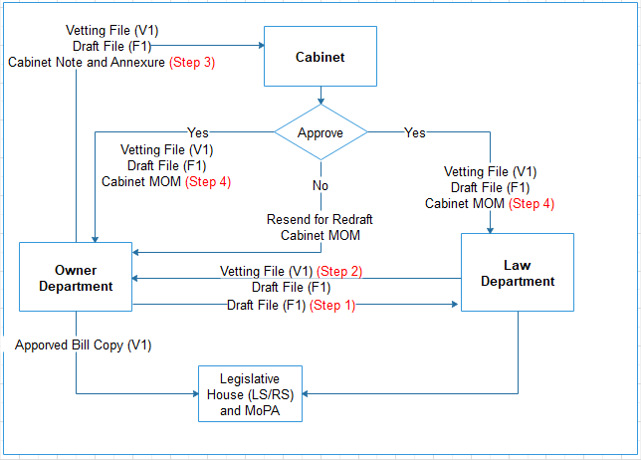

**Stakeholders Involved**

* Government Department
  + Owner Department
  + Legislative Department
  + Cabinet
  + Ministry of Parliamentary Affairs
* State/UT Legislative House
* MPs/MLAs
* Ministers

**User Registration Process for Stakeholders Involved**

Follow the user management document uploaded under [https://neva.gov.in](https://neva.gov.in/) except profile update Section as mentioned in the screen above.

* State Legislature / House (Please follow the user management document uploaded under https://neva.gov.in)
* MPs/MLAs (Please follows the user management document uploaded under [https://neva.gov.in](https://neva.gov.in/))
* Go to URL - <https://cms.neva.gov.in/>

### Process (A): User Registration Login

* Then, enter the credentials to login using user name and password to create for new user registration same as below

#### Username*: nevauser Password*: welcome

As shown in the screenshot:-

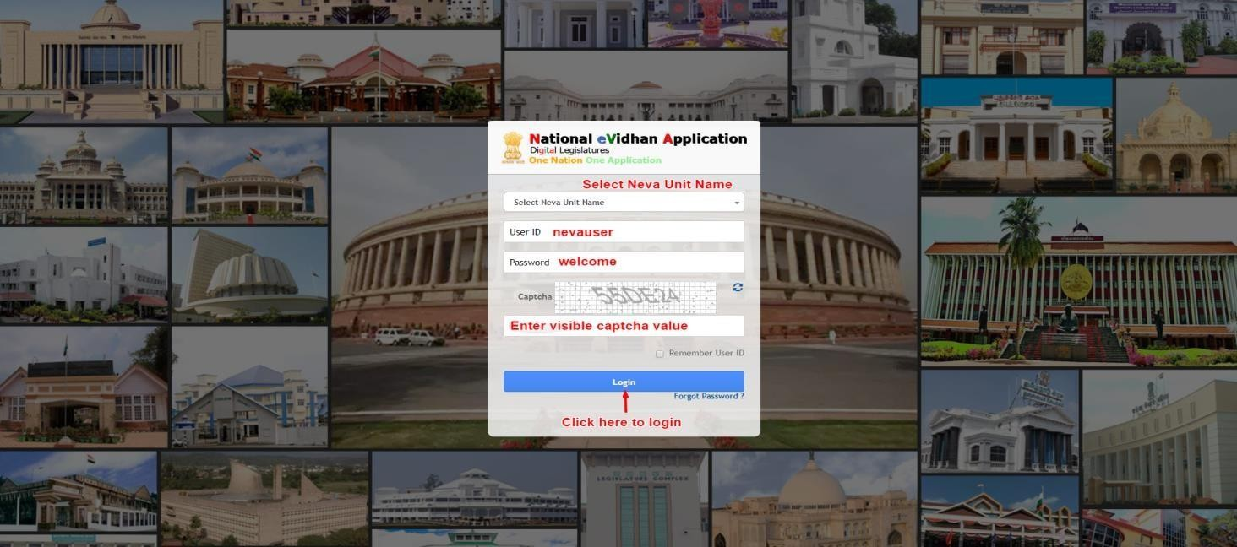

### Process (B): Registration Form

After login, the user registration form will open which is shown below:

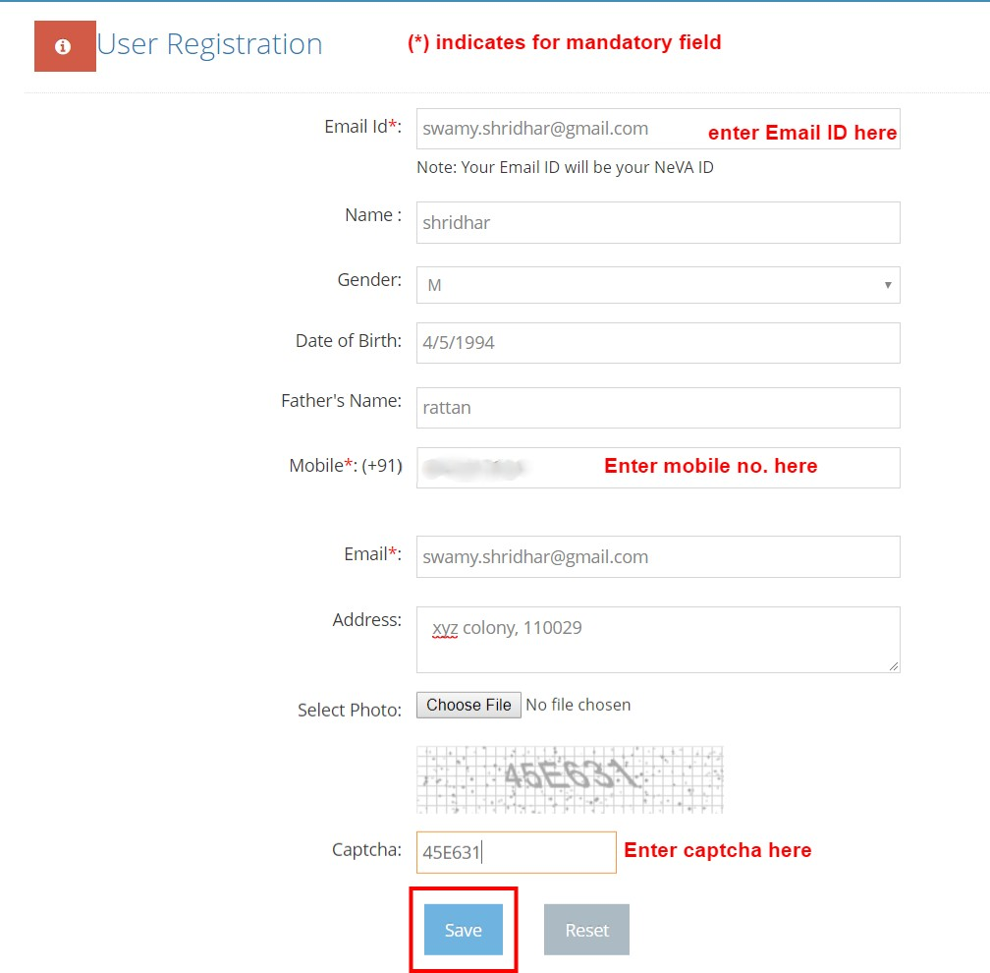

After clicking on the **“save”** button, the Successful Registration message will be prompted with User Id and Password.

Please enter the generated **NeVA Id** and **Password** in the login form .

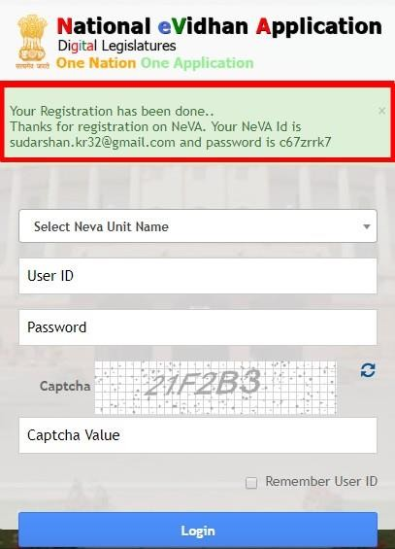

You can login with your new **NeVA User ID** and **Password** which is auto generated.

## Process (C): Profile Updating

After login, user needs to update his profile through **profile button**.

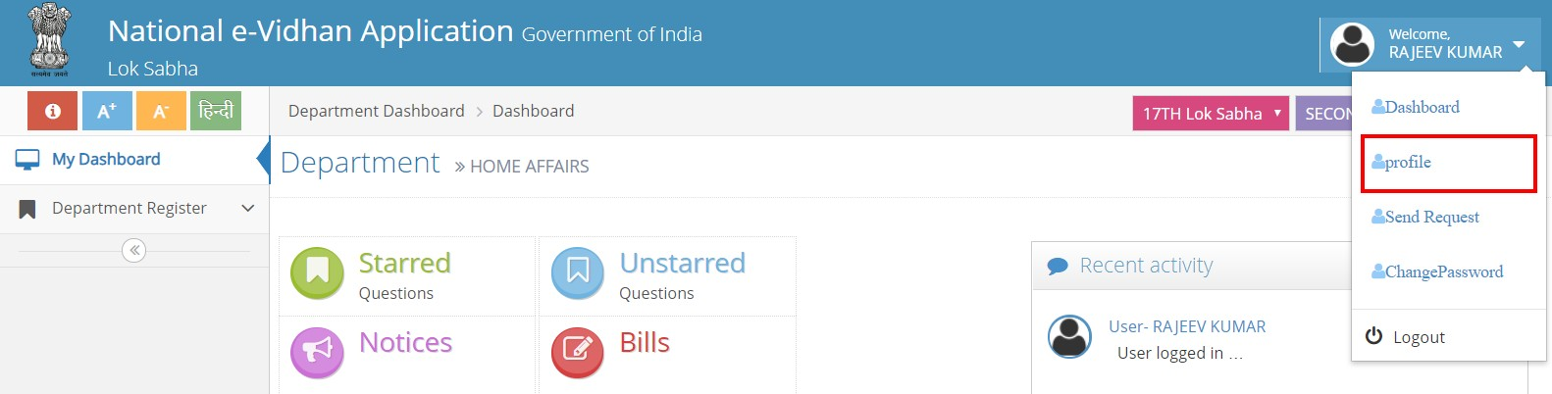

After Clicking on the **Profile button**, profile updating form will be opened which is shown below:

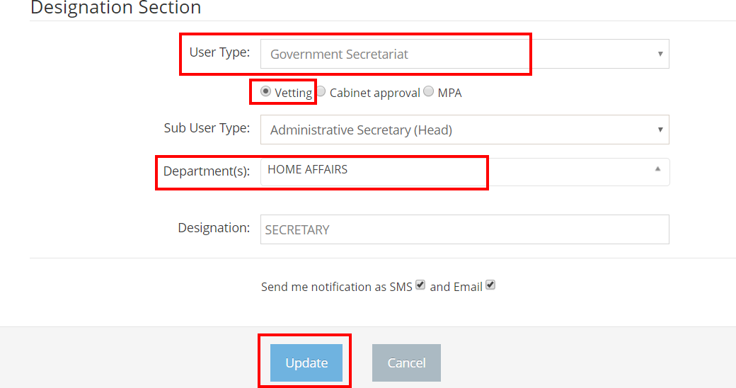

## User Type: Government Secretariat

**Sub user Type:** The dropdown value depends upon User Type. See the under mentioned list of Sub User type.

Government Secretariat

#### Administrative Secretary (Head )

**Process (D): Send Request**

After updating the profile of the member, user has to click on **“Send Request”** button which is on the bottom right corner of page under dashboard as shown below :-

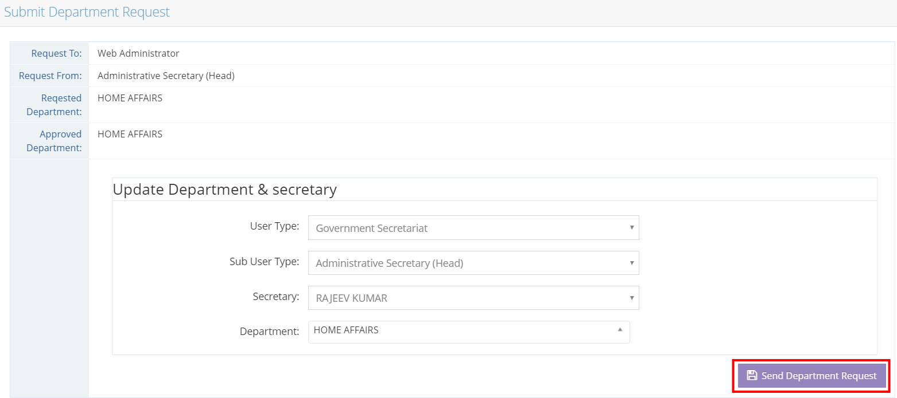

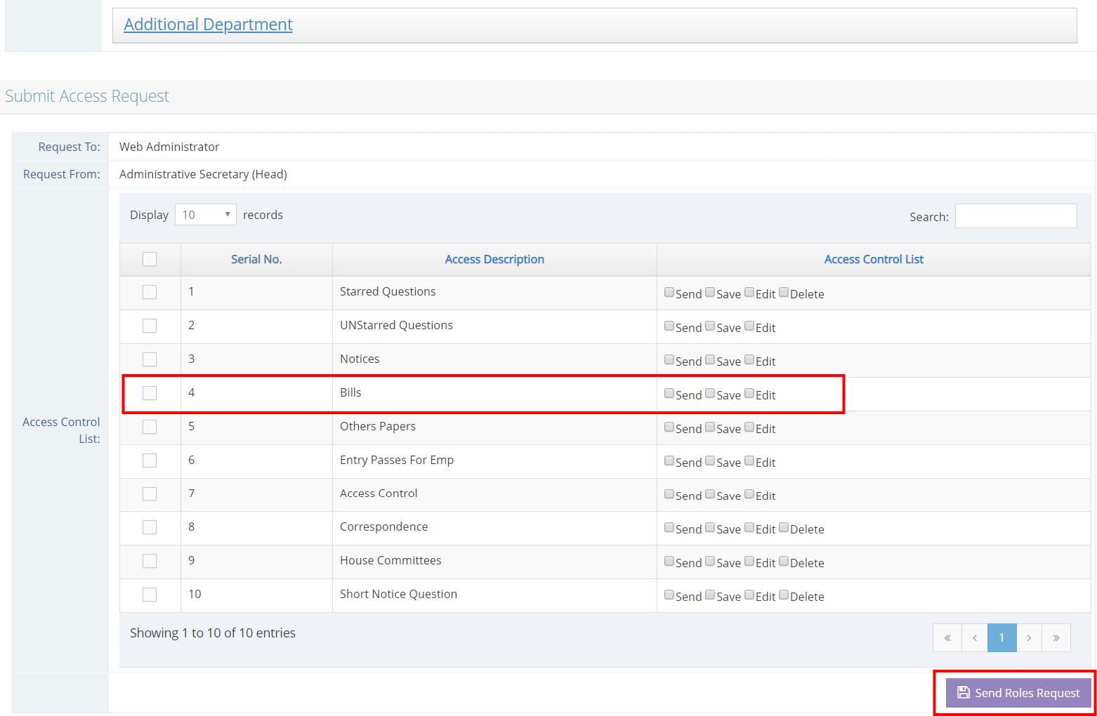

After Clicking on **“Send Role Request”** button then it shows the **“request”** list on below with pending status.

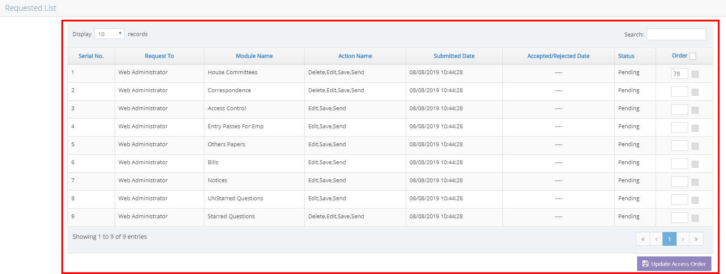

# Process (E): Approve Role Request (Access Control)

Your requested role is approved by Super Admin.

Super Admin dashboard → Access Control → Pending Request →Show all list

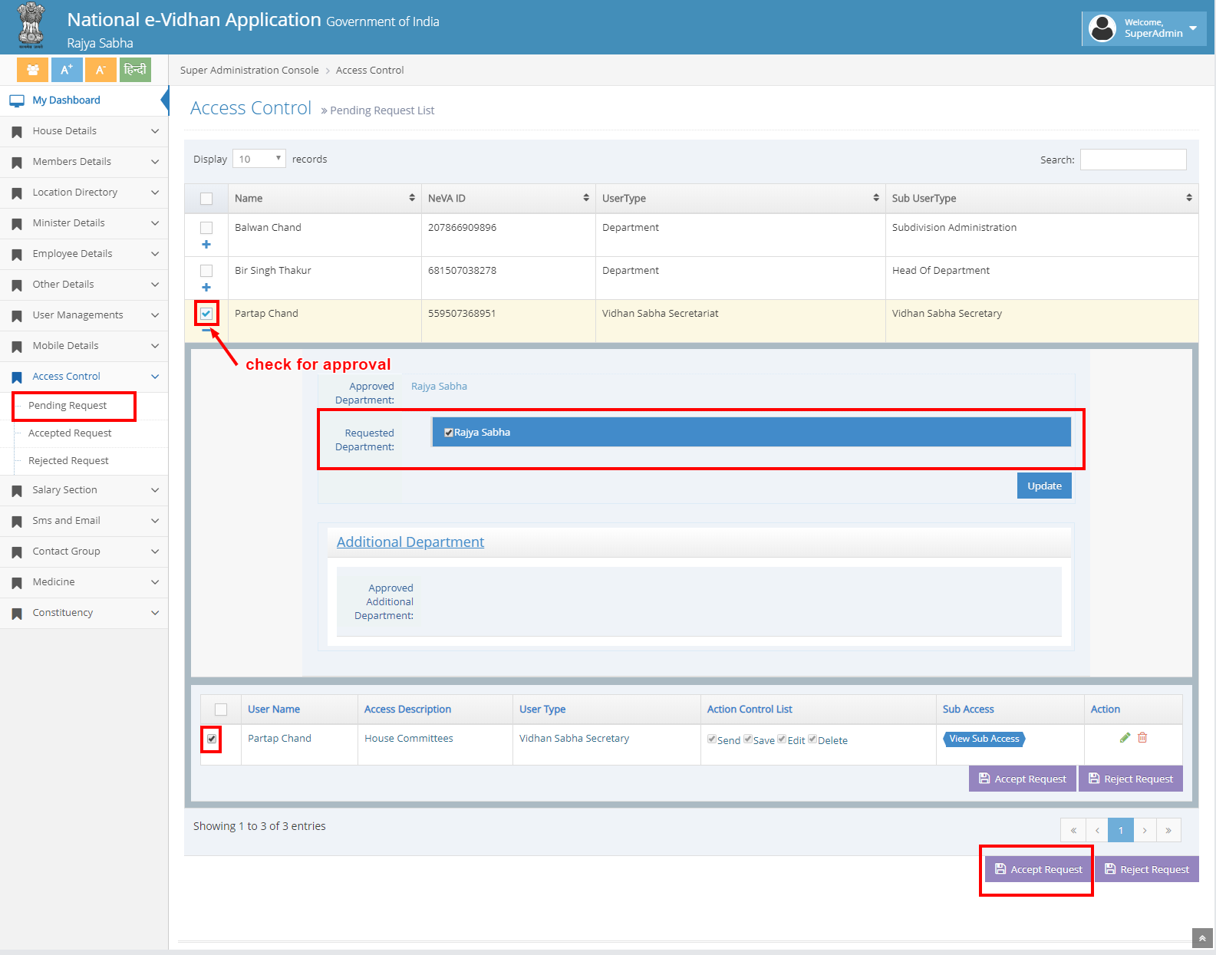

# Super Admin Dashboard

After clicking on the **“Accept Request”** button, the confirmation message will pop up and then user has to click on the **“ok”** button. Your NeVA ID is shown on the

**“Accepted Request List”**. Here you can easily search and check your NeVA ID.



search your NeVA ID.

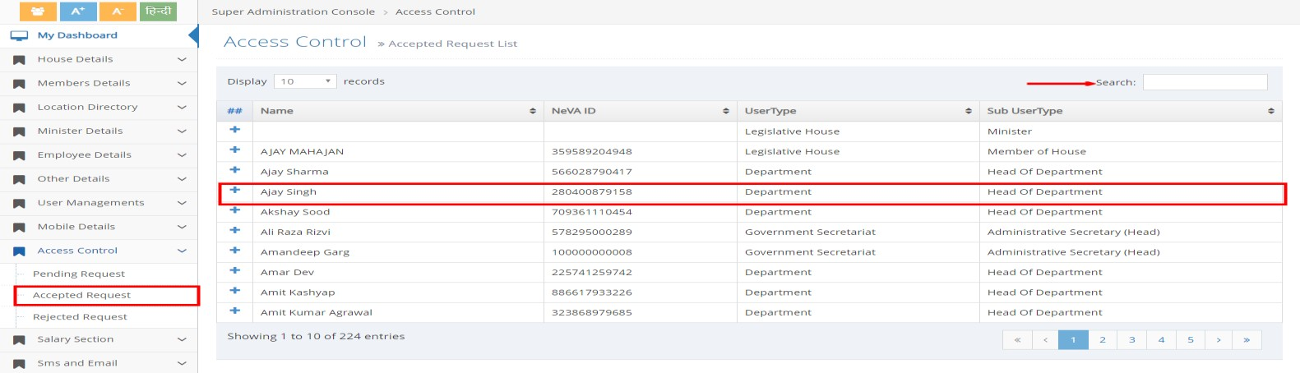

# Process (F): Approve Role Request (Access Control)

Finally After Approval of your Role Request by Super Admin, then again login with your generated **email id** or **password** in house login [https://cms.neva.gov.in.](https://cms.neva.gov.in/)

All the menus which you want to access on the left panel are enabled.

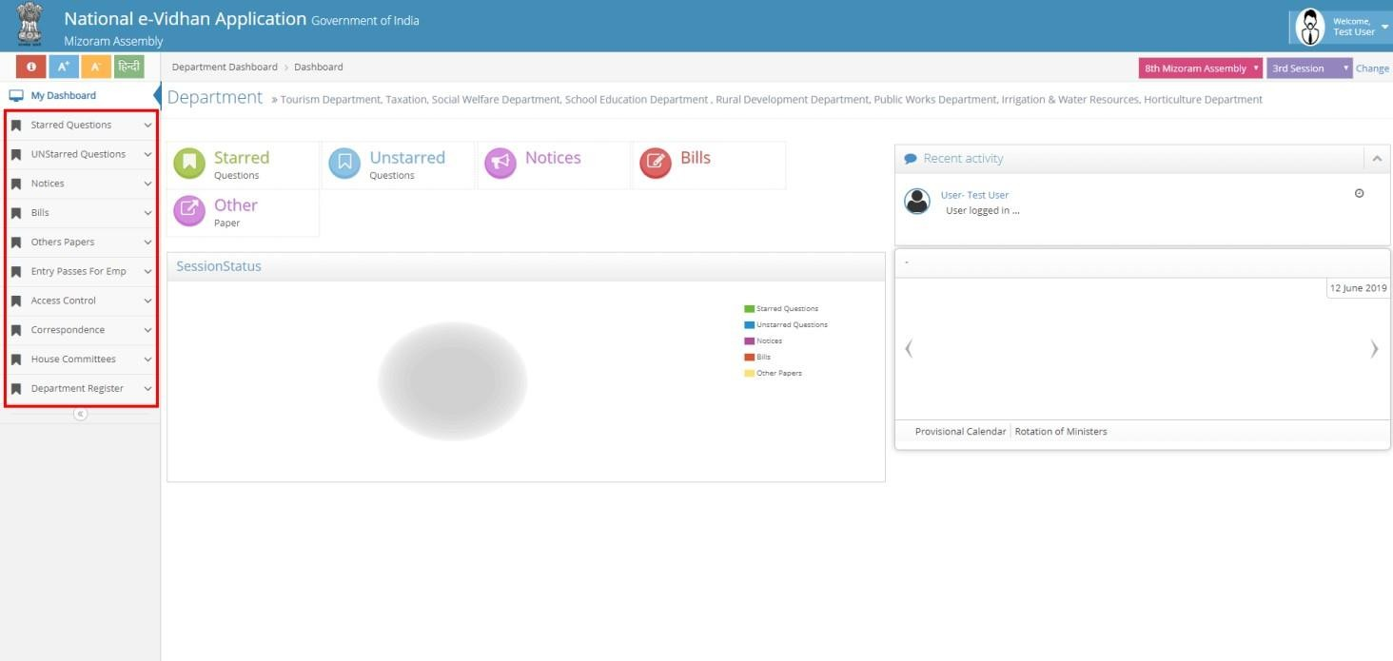

# Process 1: Draft Bill and Send for Vetting (Owner Department Login)

* + - In this process, user has to login with owner department. Then user has to go to **Bills tab** and click on **Draft Bills** tab. After clicking on **“New”** button, the Draft bills form will appear which is shown below. After filling up all the necessary data in the Draft bills form, then you have to click on the **save** button for saving your draft bill data.

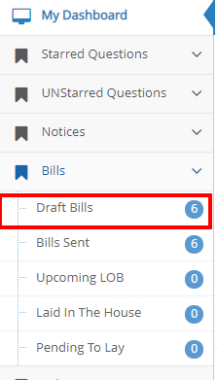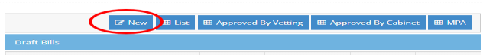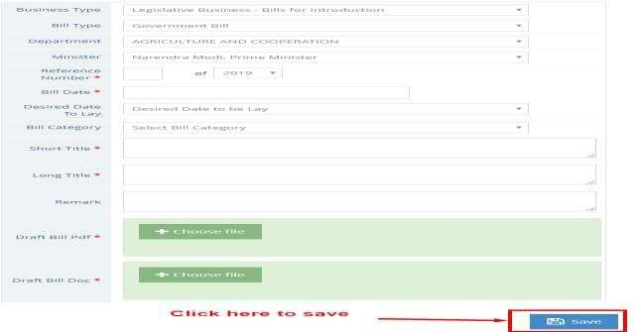

* + - After saving data, your draft bill will be displayed under draft bills list. Then user has to check the checkbox and click on **send button** (“Send for vetting”).

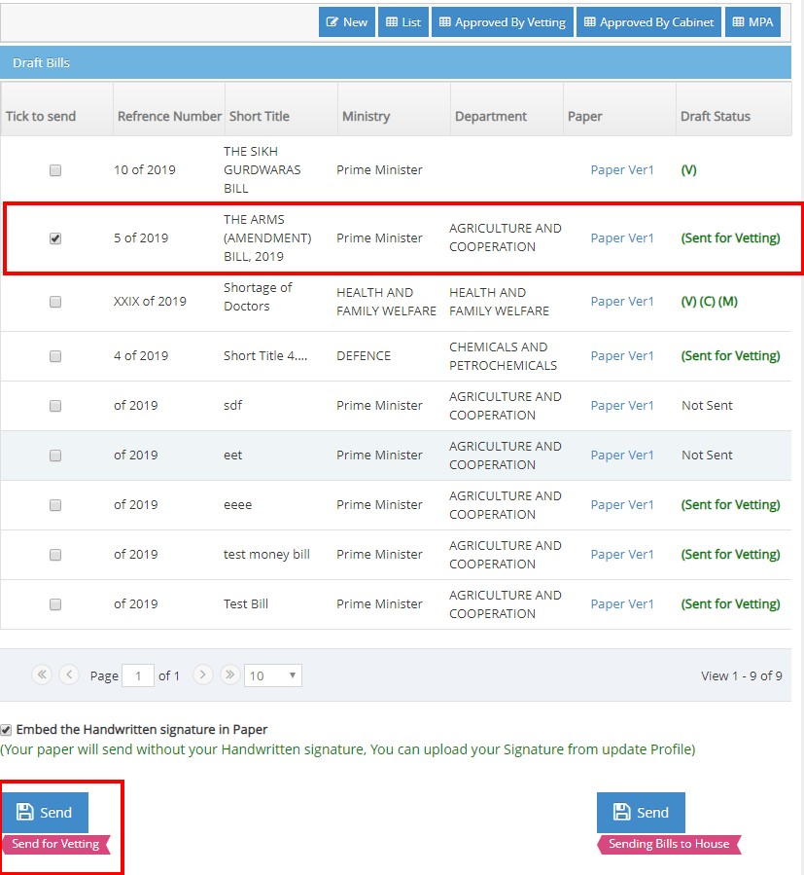

* + - If Owner department wants to send draft bill directly to associated State Legislature without vetting, then please click on **Send button** (“Sending Bills to House”)

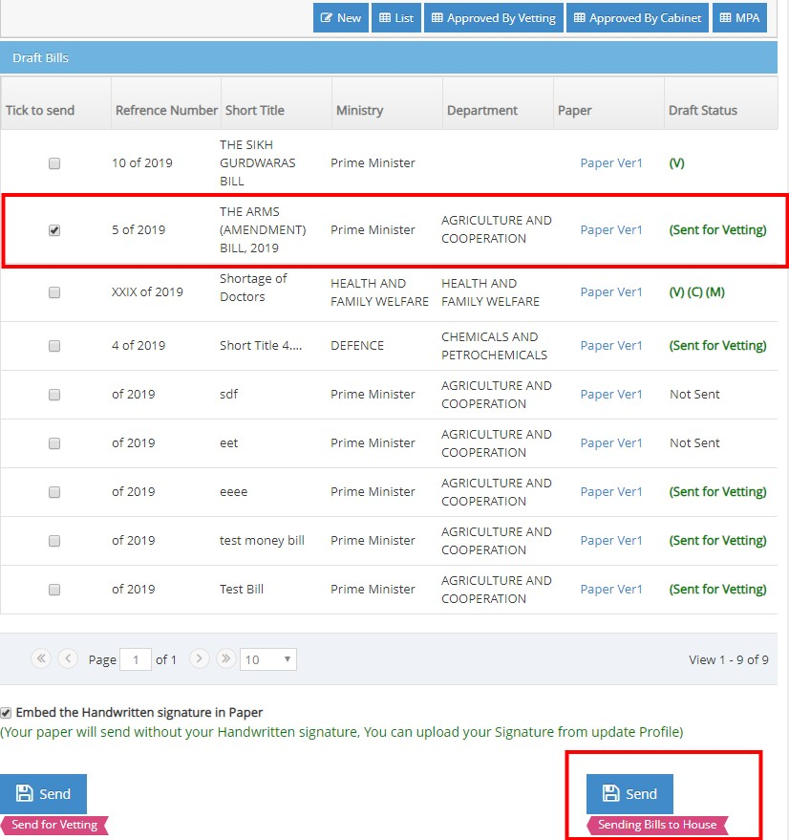

### Process 2: Upload the Vetted Bill Copy and Send to Owner Department (By Legislative Department)

* + - In this process, user has to login **with Legislative department**. Then user has to go on **Bills tab** → Draft bills. After clicking on the particular Draft bills, the Update Bill Draft form will appear which is shown below in the screenshot. After filling up all the necessary data i.e**. “ Vetting date ”**, **‘‘ Vetting PDF file’’** &

**‘‘vetting Doc file’’** in the Update Bill Draft form. Then user has to click on the

**Update button** for updating your draft bill data.

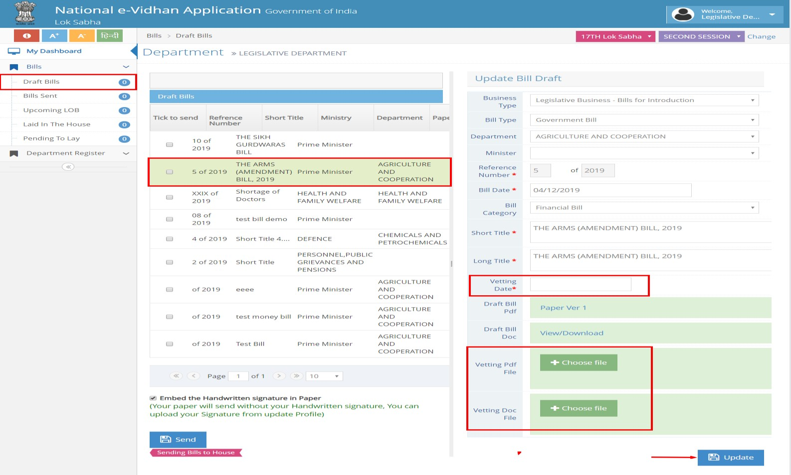

### Process 3: Vetted Bill with supported documents like Cabinet note and Annexure are sent to Cabinet for approval (Owner Department)

* + - In this process, user has to login with owner department. Then user has to go on **Bills tab** → **Draft bills**. After clicking on the **“Approved by vetting”** button, all the Draft Bills which have been vetted will be displayed in the list. Then select the particular Draft Bill item to update i.e. **Cabinet Node & Annexure**. Then user has to click on the **Update** button for updating your draft bill data.

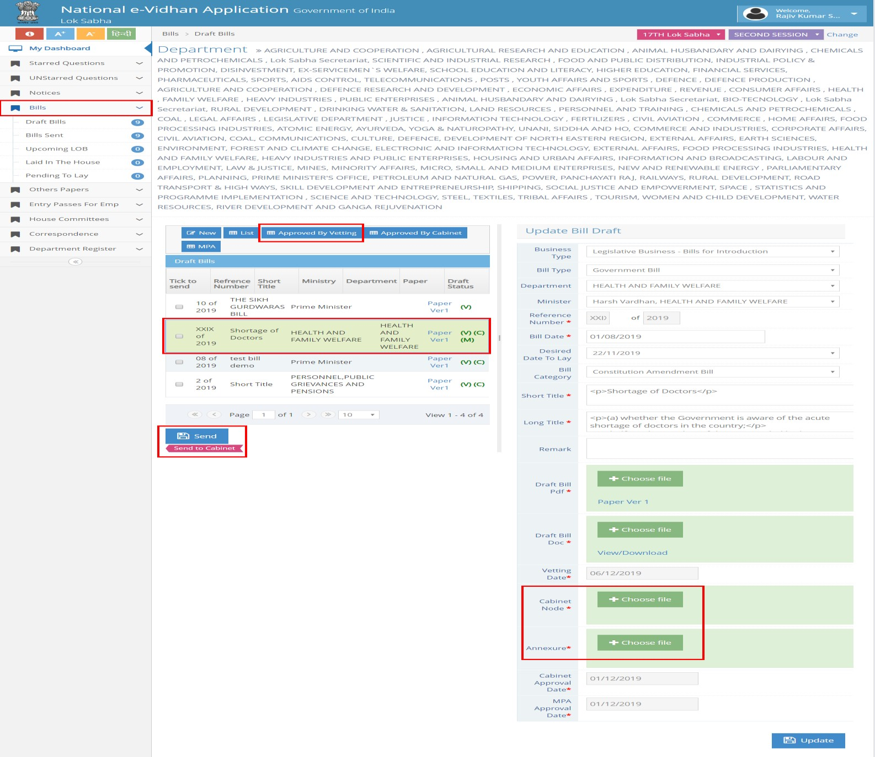

### Process 4: Draft Bill with Minutes of the Meeting (Cabinet) is sent back to Owner Department after Cabinet Approval

* + - In the Cabinet login, user will select any particular draft bill item to update **“cabinet Minutes of Meeting”**, and then click on the **Update button** for updating the draft bill data.

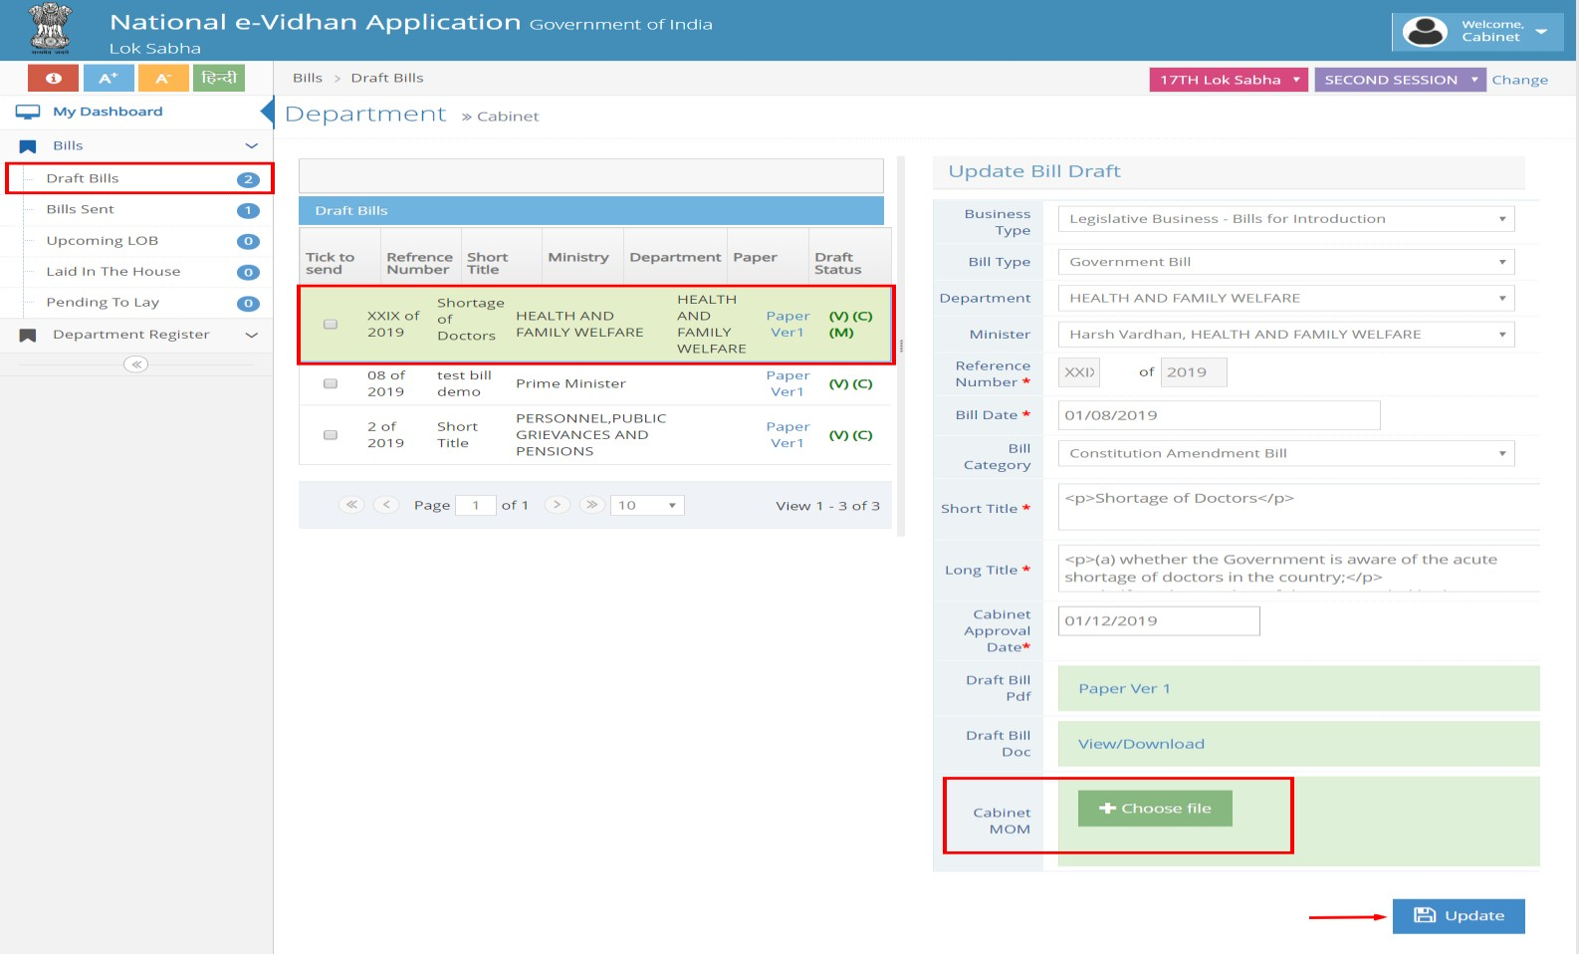

### Process 5: Cabinet Approved Draft Bill copy is sent to the State Legislature and Parliamentary Affairs Department (By Owner Department)

* + - In this process, user has to login with the owner department. Then user has to go on **Bills tab** → **Draft bills**. After clicking on the **“Approved by Cabinet”** button, then the entire **“Cabinet Approved Draft Bill”** will be displayed in the list. Then check the checkbox of the particular Draft Bill item. If the user wants to send the Cabinet Approved Draft Bills directly to house, then he/she can click on **send button** (“Send Bill to house”) or can send the Cabinet Approved Draft Bills to MPA, by clicking on the **send button** (“Send to MPA”).

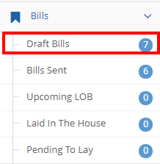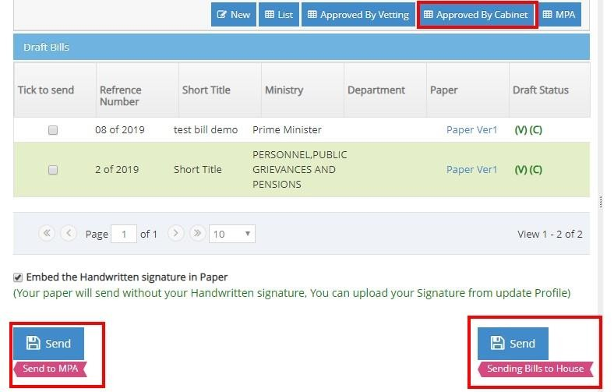

### Process 6: Optional: Cabinet Approved Bill copy to be sent to the Bicameral State Legislature and Parliamentary Affairs Department (By Legislative Department)

* + - In this process, user has to login with the Legislative Department which has the option to send the final Bill copy to either of the two Houses in case of bicameral State Legislature.

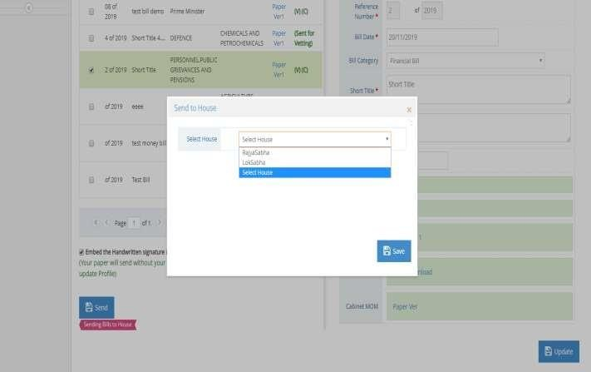

### Process 7: Bicameral State Legislature login is to view and process the Government Bills (Dashboard).

* + - In this process, the user will login with the **“State Legislative Department”**. In this login, one can view and update the draft bill which he/she has received from the Government Department.

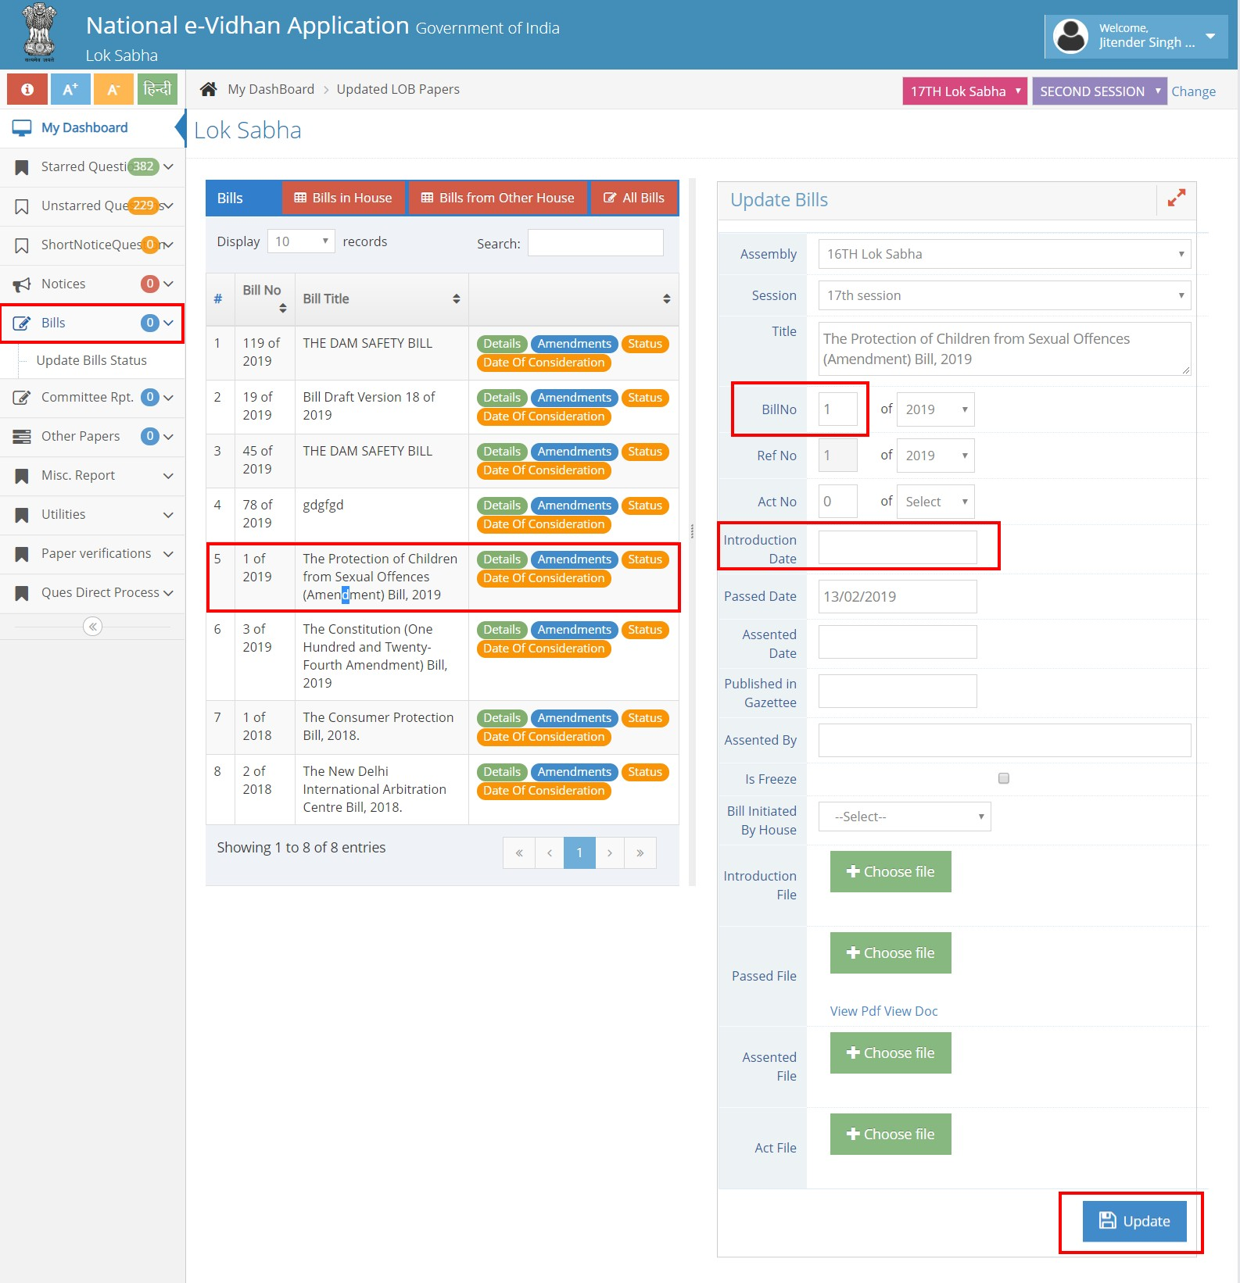

From the State Legislature login, a user can view the **‘Details of the Bill’, ‘Amendments of the Bills’, ‘Status of the Bill’, & ‘Date of consideration’** of the Bill.

* To view & Update the Draft Bill Details , user needs to click on the **“Detail”**

button:-

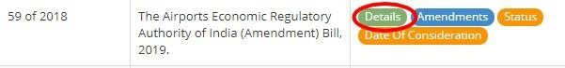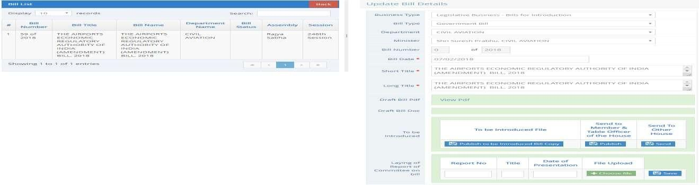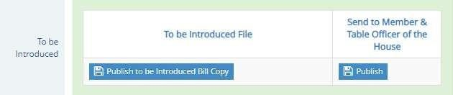

To update the **“Amendment”** of the particular Draft Bills, a user needs to click on the

**“Amendment”** button for Viewing, Adding, Deleting and Editing.

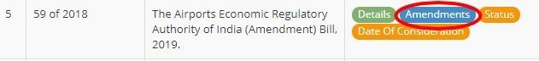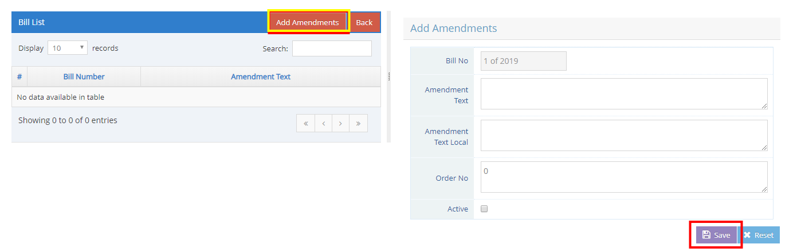

To update the **“Bill Status”** of the particular Draft Bills, a user needs to click on the

**“Status”** button for Viewing, Adding, Deleting and Editing.

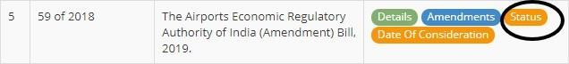

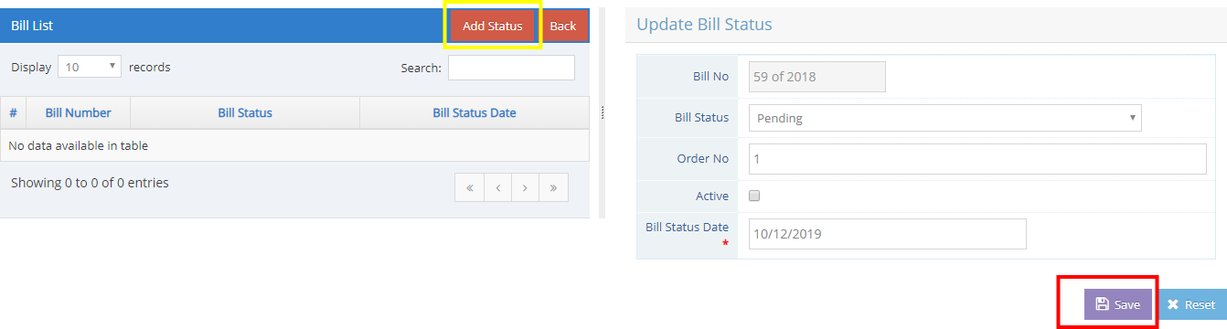

To update the **“Date of consideration”** of the particular Draft Bills, a user needs to click on the **“Date of consideration”** button for Viewing, Adding, Deleting and Editing.

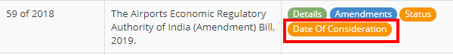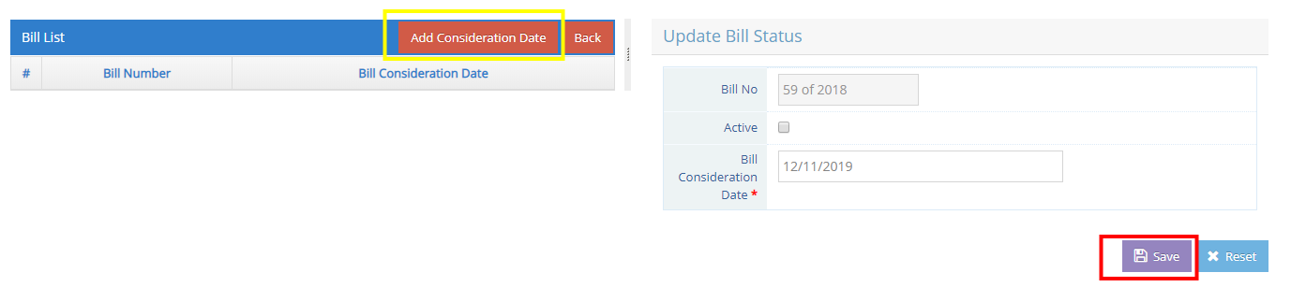

### Process 8: State Legislature Login to view and process the Draft Government Bills (Input Screen and Output: To Be Introduced and As Introduced Bill copy)

#### “To be Introduced” functionality

* 1. “Publish to be introduced Bill Copy”
     + Through this, user can generate “To be Introduced” Bill copy for a particular Bill.

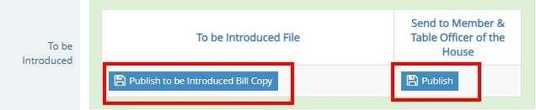

* 1. “Publish”
     + Through this, a user can publish the generated “To be Introduced” Bill copy to the Member of the State Legislature.

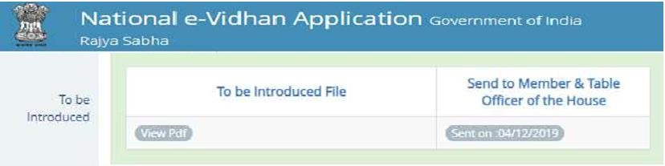

**“As Introduced” functionality**

#### “Publish As introduced Bill Copy”

* + Through this, a user can generate and publish **“As Introduced”** Bill copy for the particular bill.

#### “Send to e- gazette”

* + Through this, user can confirm that they provided **“As Introduced”** Bill copy to the e-gazette Office.

#### “Send to Other House”

* + Through this, a user can transfer or send the **“As Introduced”** Bill copy to the other State Legislature House, in case of Bicameral State Legislature.

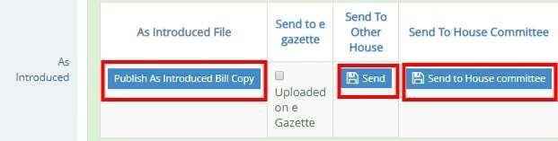

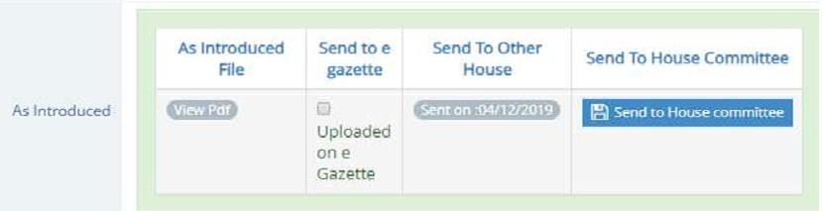

#### “Send to House Committee”

* + Through this, a user can send the **“As Introduced”** Bill copy to the House Committee for further recommendation.

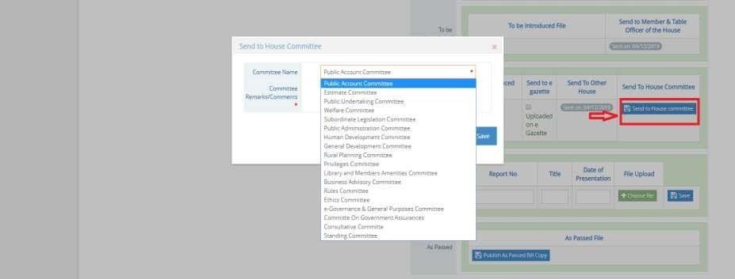

* **“As passed Bill copy”** functionality
  + Through this, a user can publish the **“As Passed”** Bill copy for a particular Bill.

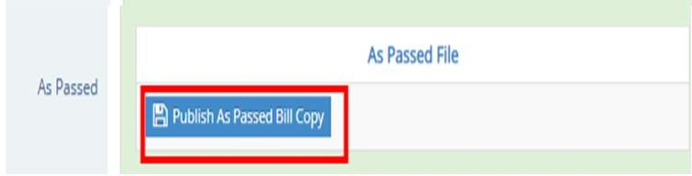

# Process 9: (Advance copy of “To be introduced” is available at MPs/MLAs login)

In MPs/MLAs login, Advance copy of **“To be introduced”** is available at Assembly Bills tab.

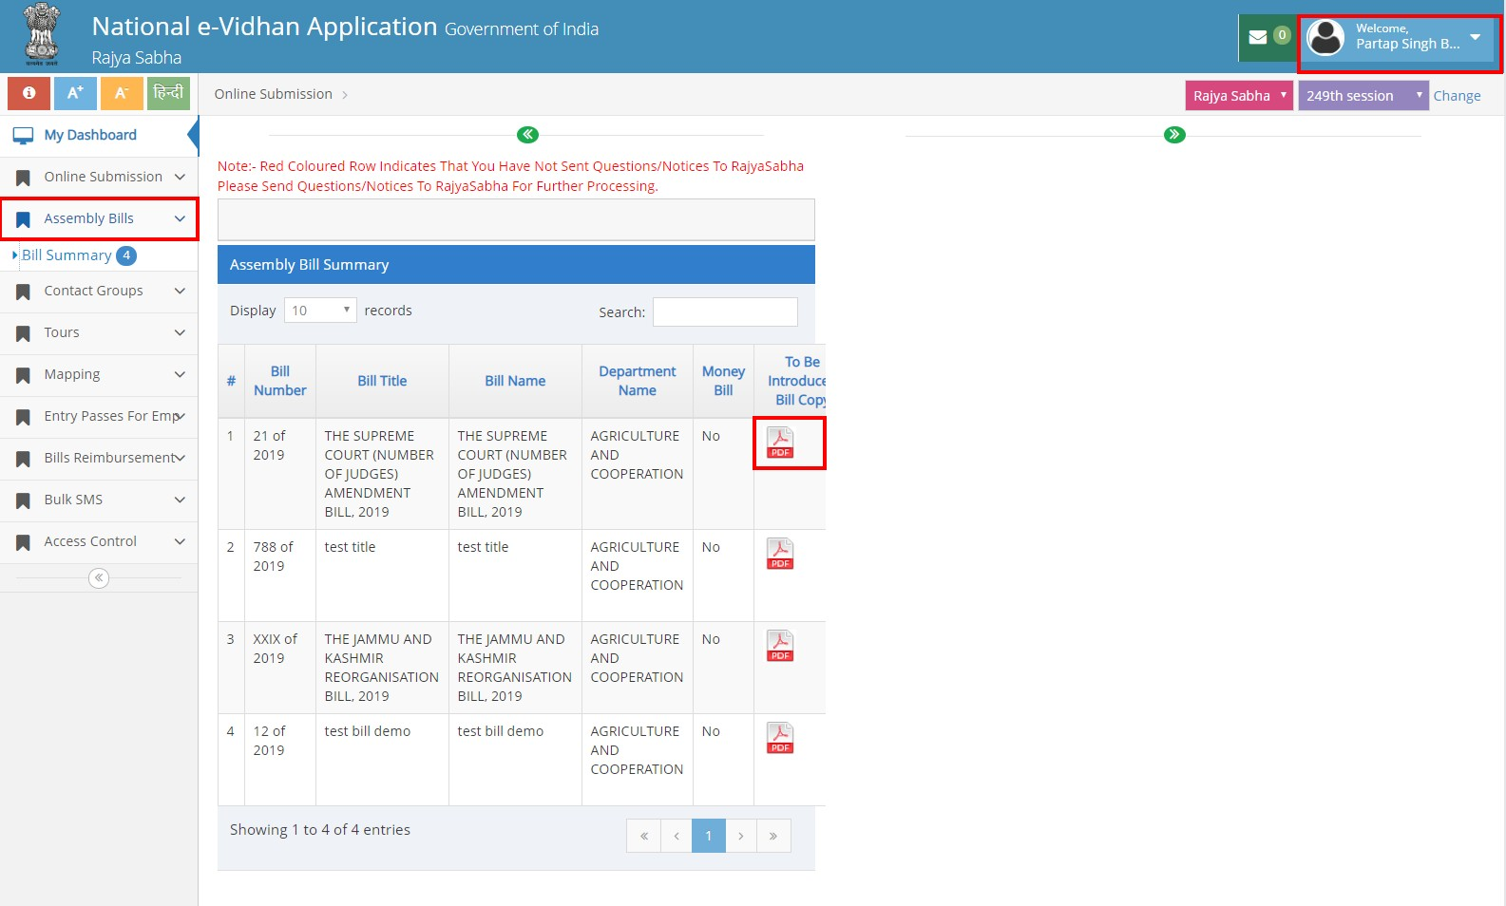

# Process 10: As Introduced Bill copy is sent to other Legislature House

To view the State Legislature Bill copy, a user can click on **Bills** → **Update Bill** status tab

**“Bill from the other house”** in case of bicameral state legislature.

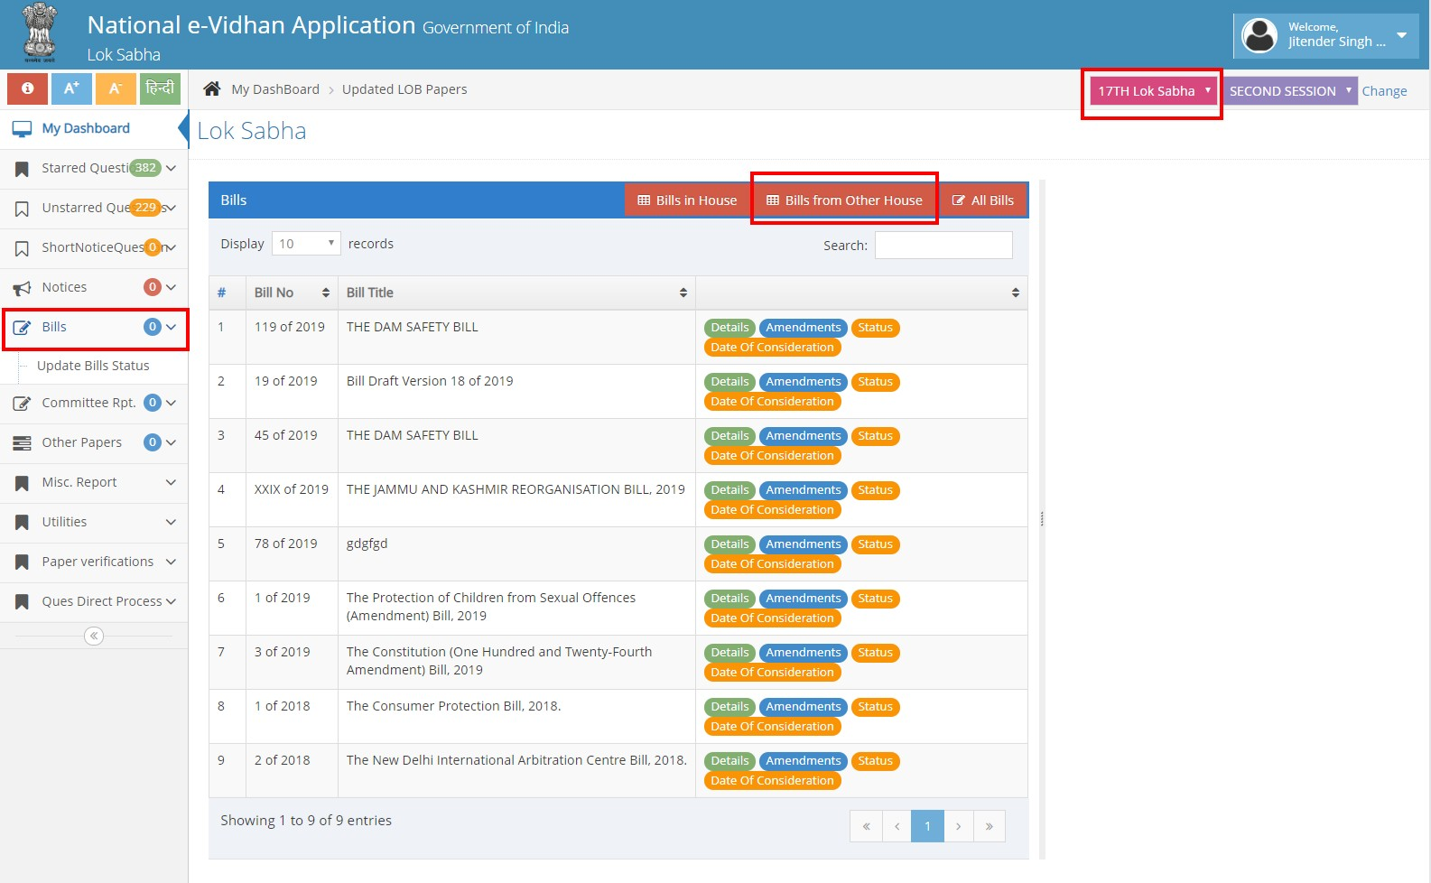

# Process 11 :( Bill copy available at “List of Business” for making LOB of the day)

User can view and attached the required Bill copy from the **“view paper”** & **“Show paper”** button from list of business login.

