|  |  |  |  |  |  |  |  |
| --- | --- | --- | --- | --- | --- | --- | --- |
| Establishment  Name & Address | Universal  Account Number | PF Account  Number | Date of joining  (DD/MM/ YYYY) | Date of exit  (DD/MM/ YYYY) | Scherrie  Certificate No. (if issued | PPO Number  (if issued) | Non  Contributory Period (NCP) Days |
|  |  |  |  |  |  |  |  |

|  |  |  |  |  |  |  |
| --- | --- | --- | --- | --- | --- | --- |
| Name & Address of the  Trust | UAN | Member EPS A/c Number | Date of joining (DD/MM/  YYYY) | Date of exit (DD/MM/ YYYY) | Scheme Certificate No. (if  issued | Non Contributory Period (NCP)  Days |
|  |  |  |  |  |  |  |

## [www.epfindia.eov.in](http://www.epfindia.eov.in/)

Composite Declaration Form -11

## EMPLOYEES’ PROVIDENT FUND ORGANISATION

Employee’ Provident Funds **Scheme, 1952** (Paragraph 34 & 57) & Employee’s Pension **Scheme, l99S (Paragraph 24)**

|  |  |  |
| --- | --- | --- |
|  | Name of the member | Dhruv Khatana |
| 2 | Father’s Name /  Spouse’s Name | Deshpal Singh |
| 3 | Date of Birth: ( DD / MM / YYYY ) | 29/09/2000 |
| 4 | Gender: (Male/Female/Transgender) | Male |
| 5 | Marital Status: (Married/Unmarried Widow/Widower/Divorcee) | Unmarried |
| 6 | (a) Email ID:  (b} Mobile No.: | [dhruv.khatana29@gmail.com](mailto:Dhruv.khatana29@gmail.com)  9560899601 |
| 7 | **Present employment details:**  Date of joining in the current establishment (DD/MM/YYYY) | 5/10/2023 |
| 8 | KYC Details: (attach self-attested copies of following KYCs) |  |
| 1. Bank Account No. : 2. IFS Code of the branch: | 604810110004541  BKID0006048 |
| ( C) Aadhar Number | 750307118978 |
| ( d) Permanent Account Number (PAN), if available | JSLPK1925E |
| 9 | Whether earlier a member of Employees’ Provident Fund Scheme,1952 | No |
| 10 | Whether earlier a member of Employees’ Pension Scheme, 1995 | No |
|  | **Protons employment details: [if** Yes to 9 AND / OR **l0 above]** - **Un-exempted** | |
| 12 | **Previous employment details: [If** Yes to 9 AND/OR 10 Above] — **For Exempted Trusts** | |
| 13 | **a) International Worker:** | No |
| b) If yes, state country of origin (India/Name of other country) |  |
|  |  |
| d) Validity of passport [(DD/MM/YYYY) to (DD/MM/YYYY)] |  |

UNDERTAKING

* 1. Certified that the particulars are true to the best of my knowledge.

1. 1 authorize EPFO to use my Aadhar for verification/authentication/e-KYC purpose for service delivery.
2. Kindly transfer the funds and service details, if applicable, from the previous PF account as declared above to the present PT. Account as I am an Aadhar verified employee in my previous PF Account.*
3. In use of changes in alive details, the same will be intimated to employer at the earliest.

New Delhi 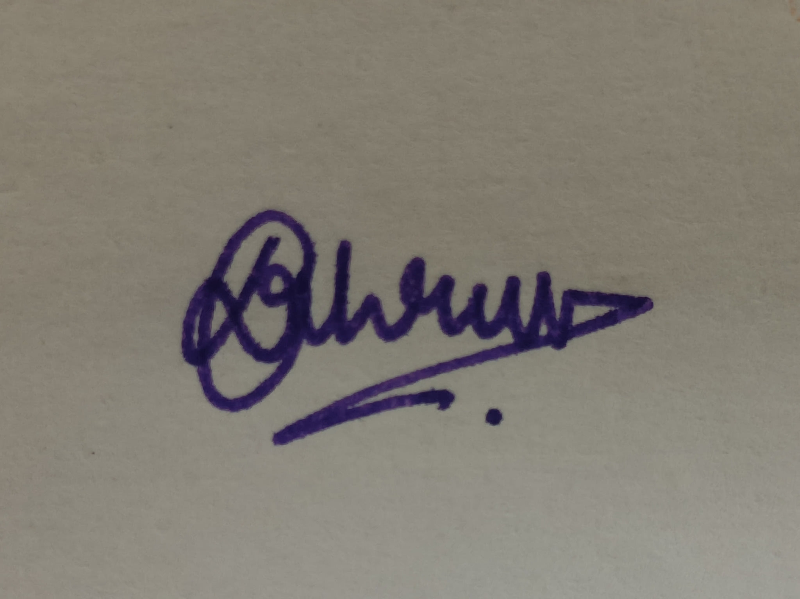

Place Signature of Member

**DECLARATION BY PRESENT** **EMPLOYER**

1. The Member Mr/Ms./Mrs......................................................................... has joined on ..................................and has been allotted PF No. .......................................................and U'AN.................................................................................................
   1. In case the person was earlier not a member of EPF Scheme, 1952 and UPS, 1995:
      * Please Tick the Appropriate Option:

The KYC details of the above member in the UAN database

* + - Have not been uploaded
    - Have been uploaded but not approved
    - Have been uploaded and approved with DSC/e-sign.
  1. In case the person was earlier a member of EPF Scheme, 1952 and UPS1995:
* Please Tick the Appropriate Option:-

O The KYC details of the above member in the UAN database have been approved with E-sign/Digital Signature Certificate and transfer request has been generated on portal

O The previous Account of the member is not Aadbar verified and hence physical transfer form shall be initiated

Date: Signature of Employer with Seal of

Establishment

*Auto transfer of’ previous PF account would be possible in respect of Aadhar verified employees only. Other employee’s arc requested to file physical claim (Form-13) fa transfer of account from the previous establishment.